**Veterans Health Administration  
Office of Informatics and Analytics**

**Connected Health**

**Veterans/Consumers Health Informatics Office**

Requirements Development Management

**My HealtheVet Redesign Dashboard Menu**

New Service Request #20120315

*Business Use Case*



December 2015

Revision History

|  |  |  |  |
| --- | --- | --- | --- |
| Date | Version # | Description | Author |
| 12/14/2015 | .1 | Create Draft BUC | L. Johnson |
| 12/18/2015 | .2 | PM Review | R. Weaver |
| 12/21/2015 | .3 | PM Edits | L. Johnson |
| 01/05/2016 | .4 | Incorporated additional changes as per C. Scruggs | L. Johnson |
| 01/11/2016 | .5 | Incorporated additional changes as per C. Scruggs and N. Abolarin | L. Johnson |
| 01/14/2016 | .6 | Incorporated changes from V/CHIO review | L. Johnson |
| 1/14/2016 | .7 | Baselined for Phase 1 | L. Johnson |
| 2/16/2016 | .8 | Began updates for Phase 2 | R. Weaver |
| 2/18/2016 | .9 | Incorporated additional changes as per C. Scruggs and V/CHIO review | L. Johnson |
| 2/26/2016 | .10 | Incorporated additional changes per review | L. Johnson |
| 3/2/2016 | .11 | PM Edits | L. Johnson |
| 3/15/2016 | .12 | Incorporated additional changes to types of user accounts | L. Johnson |
| 3/28/2016 | .13 | Added in the updated mockups and new alternative flows for blue button download | L. Johnson |
| 3/31/2016 | .14 | Added Resource URL links and Screenshots | L. Johnson |
| 4/22/2016 | .15 | Added Approved Content from N. Abolarin | L. Johnson |
| 5/11/2016 | .16 | New Login box deferred to future release | R. Weaver |
| 5/20/2016 | .17 | Updated Content and added Draft mockups | L. Johnson |
| 5/31/2016 | .18 | Added Draft Content for a Non-VA Patient Basic or Advanced Logged In | L. Johnson |

Table of Contents

[1. My Health*e*Vet Dashboard Menu 1](#_Toc450723760)

[1.1. Brief Description 1](#_Toc450723761)

[2. Preconditions 2](#_Toc450723762)

[3. Basic Flow of Events 2](#_Toc450723763)

[3.1. My Health*e*Vet Dashboard – A User Not Logged In 2](#_Toc450723764)

[3.1.1. My Health*e*Vet Dashboard – Blue Menu Buttons 4](#_Toc450723765)

[4. Alternative Flows 4](#_Toc450723766)

[4.1. My Health*e*Vet Dashboard – User Logged In 4](#_Toc450723767)

[4.1.1. My Health*e*Vet Dashboard Sub Menu – Pharmacy 7](#_Toc450723768)

[4.1.2. My Health*e*Vet Dashboard Sub Menu - Appointments 8](#_Toc450723769)

[4.1.3. My Health*e*Vet Dashboard Sub Menu – Messages 8](#_Toc450723770)

[4.1.4. My Health*e*Vet Dashboard Sub Menu – Health Records 8](#_Toc450723771)

[4.1.5. Pharmacy Functionality – Non-VA Patients with Basic or Advanced Accounts 9](#_Toc450723772)

[4.1.6. Appointments - Non-VA Patients with Basic or Advanced Accounts 10](#_Toc450723773)

[4.1.7. Secure Messaging – Non-VA Patients with Basic or Advanced Accounts 10](#_Toc450723774)

[4.1.8. Health Records – Non-VA Patients with Basic or Advanced Accounts 11](#_Toc450723775)

[4.1.9. Pharmacy - VA Patients with an Advanced Account or Premium Account - First Time Access 11](#_Toc450723776)

[4.1.10. Appointments - VA Patients with an Advanced Account 12](#_Toc450723777)

[4.1.11. Messages - VA Patients with an Advanced Account 12](#_Toc450723778)

[4.1.12. Health Records – VA Patients with an Advanced Account 12](#_Toc450723779)

[4.2. My Health*e*Vet Dashboard – User Logged In through eBenefits 14](#_Toc450723780)

[5. Special Requirements 14](#_Toc450723781)

[5.1. Sub Menu – When Selected 14](#_Toc450723782)

[6. Post Conditions 14](#_Toc450723783)

[Appendix A Acronyms and Definitions 15](#_Toc450723784)

[Appendix B Business Use Case Flow Models 16](#_Toc450723785)

[Appendix C Pharmacy Article URL Link 26](#_Toc450723786)

[Appendix D Appointment Article URL Link 27](#_Toc450723787)

[Appendix E Messages Article URL Link 28](#_Toc450723788)

[Appendix F Health Records Article URL Link 29](#_Toc450723789)

[Appendix G MHV Splash Page 30](#_Toc450723790)

[Appendix H Account Messages 31](#_Toc450723791)

[Appendix I Approval Signatures 42](#_Toc450723795)

# My Health*e*Vet Dashboard Menu

## Brief Description

This Business Use Case (BUC) is to detail the requirements needed for the MHV visitors and users to view and select key features from a dashboard design. The MHV Homepage will have a new dashboard section added to the top of the page. The dashboard will provide the ability for the user to quickly navigate to popular features.

**Dashboard Lite Phase 1:**

* Updated Homepage view for users not logged into MHV.
  + Introduction of a new dashboard with links to read more about Pharmacy, Appointments, Messages, and Health Records.
  + Introduction of new “Resources” section
* Updated landing page view for users who are logged into MHV.
  + Introduction of a new dashboard providing quick access to frequently used features in Pharmacy, Appointments, Health Records, and Secure Messaging landing page.
  + Introduction of new “Resources” section
* Updated content:
  + Dashboard menu/submenu names

**Dashboard Lite Phase 2:**

* Updated content:
  + Pharmacy submenu: updated content for users without correct credentials.
    - All Pharmacy submenus display same content to users that do not have correct credentials to access.
  + Appointments page: updated content for users without correct credentials.
  + Secure Messaging page: updated content for users without correct credentials.
* Display Defects: Every Menu/All Functionality should not display for all users
  + Non-VA Patients should not see “Secure Messaging” menu or “Messages” on dashboard.
  + Non-VA Patients should not see “Health Summary” as a submenu on Health Records
* Defects found in May 2016 UAT Testing:
  + Health Summary Navigation from dashboard should take user to the My VA Health Summary Download Results page.
  + Capture an AAL when Health Summary is selected from the dashboard

**Future Release: Release Date TBD**:

* Updated design for Homepage view for users not logged into MHV.
  + Introduction of new “Login or Register” button
* Updated design for landing page view for users who are logged into MHV.
  + New logout box section

| Event | Actor |
| --- | --- |
| Dashboard Menu | Users and Visitors |
| Sub Menu | User |
|  |  |

User and Visitor

Dashboard Menu

**Business Use Case Diagram**

Sub Menu

# Preconditions

* The MHV has migrated to the LifeRay Content Management System.
* The MHV is online.
* The MHV splash page has been removed.

# Basic Flow of Events

## My Health*e*Vet Dashboard – A User Not Logged In

**Step 1:** The Actor navigates to the My Health***e***Vet website ([www.myhealth.va.gov](http://www.myhealthevet.va.gov)).

**Step 2:** The system shall display the revised MHV home page. (Phase 1 see[**Figure 1**](#Figure_1)) (Phase 2 see **Figure 13**). Refer to Alternative Flow **4.1** if the User logs into MHV.

* The MHV splash page will not appear (see[**Figure 21**](#Figure_17)).

**Step 3:** **Phase 1:** The system shall display four blue menu buttons for Pharmacy, Appointments, Messages and Health Records with white sub menu text boxes shown below providing the following content:

* Pharmacy
  + “Refill your VA prescriptions, track delivery, view a list of your VA medications with instructions and other details…[Read more](Article:%20%20Managing%20your%20prescriptions)” (Approved 1/11/16)
* Appointments
  + “Keep track of your upcoming VA medical appointments and get email reminders…[Read more](Article:%20%20Keeping%20up%20with%20all%20your%20VA%20appointments)” (Approved 1/11/16)
* Messages
  + “Communicate securely online with your VA health care team (or other VA staff) about non-emergency information or questions …[Read more](Article:%20Secure%20Messaging)” (Approved 1/11/16)
* Health Records
  + “View, print, download and share a copy of your VA medical record information, or track your own health information…[Read more](Article:%20%20Download%20Your%20Own%20VA%20Medical%20Records)” (Approved 1/11/16)

**Phase 2:** The system shall display the dashboard section with updated design but existing content listed in Phase 1, followed by “Resources” section. **(New for Phase 2)** (See **Figure 13**)

**Step 4:** The User selects the Pharmacy [Read more](Article:%20%20Managing%20your%20prescriptions) hyperlink and the system displays the article “Managing your prescription refills” see **Appendix C**

**Step 5:** The User selects the Appointments [Read more](Article:%20%20Keeping%20up%20with%20all%20your%20VA%20appointments) hyperlink and the system displays the article “Keeping up with all your VA Appointments” see **Appendix D**

**Step 6:** The User selects the Messages [Read more](Article:%20Secure%20Messaging) hyperlink and the system displays the article “Secure Messaging” see **Appendix E**

**Step 7:** The User selects the Health Records [Read more](Article:%20%20Download%20Your%20Own%20VA%20Medical%20Records) hyperlink and the system displays the article “Download Your Own VA Medical Records” see **Appendix F**

**Step 8:** The User selects the Home menu and the system displays the MHV homepage and dashboard.

**Step 9:** The User selects “Benefits” hyperlink from the “Resources” section and the system displays the VA Benefits page (see **Figure 32**).

**Step 10:** The User selects the Home menu and the system displays the MHV homepage.

**Step 11:** The User selects “Mental Health” hyperlink from the “Resources” section and the system displays the Mental Health page (see **Figure** **33**).

**Step 12:** The User selects the Home menu and the system displays the MHV homepage.

**Step 13:** The User selects “Community” hyperlink from the “Resources” section and the system displays the Community page (see **Figure 34**).

**Step 14:** The User selects the Home menu and the system displays the MHV homepage.

**Step 15:** The User selects “Medical Library” hyperlink from the “Resources” section and the system displays the Veteran’s Health Library (see **Figure 35**).

**Step 16:** The User selects the Home menu and the system displays the MHV homepage.

**Step 17:** The User selects “Healthy Living” hyperlink from the “Resources” section and the system displays the Healthy Living page (see **Figure 36**).

**Step 18:** The User selects the Home menu and the system displays the MHV homepage.

**Step 19:** The User selects “Health Calendar” hyperlink from the “Resources” section and the system displays the Health Calendar page (see **Figure 40**).

**Step 20:** The User selects the Home menu and the system displays the MHV homepage.

**Step 21**: The User selects “Health***e***Living Assessment” hyperlink from the “Resources” section and the system displays the Health***e***Living Assessment page (see **Figure 39**).

**Step 22:** The User selects “Show All Resources” hyperlink from the “Resources” section and the system displays the Resources page (see **Figure 41**).

This user flow ends.

### My Health*e*Vet Dashboard – Blue Menu Buttons

This user flow continues from the Basic Flow 3.1 Step 3

**Step 1:** The system shall display the four blue menu buttons for Pharmacy, Appointments, Messages and Health Records.

**Step 2:** The User selects the Pharmacy blue menu button.

**Step 3:** The system displays the Pharmacy article (see **Appendix C**).

**Step 4:** The User selects the Home menu and the system displays the MHV homepage and dashboard.

**Step 5:** The User selects the Appointments blue menu button.

**Step 6:** The system displays the Appointments article (see **Appendix D**).

**Step 7:** The User selects the Home menu and the system displays the MHV homepage and dashboard.

**Step 8:** The User selects the Messages blue menu button.

**Step 9:** The system displays the Messages article (see **Appendix E**).

**Step 10:** The User selects the Home menu and the system displays the MHV homepage and dashboard.

**Step 11:** The User selects the Health Records blue menu button.

**Step 12:** The system displays the Health Records article (see **Appendix F**).

**Step 13:** The User selects the Home menu and the system displays the MHV homepage and dashboard.

This user flow ends.

# Alternative Flows

## My Health*e*Vet Dashboard – User Logged In

**Step 1:** The User logs into their account from the My Health***e***Vet website or AccessVA website. (Alternative flow [**4.2**](#altFlow_eBenefits) User logs in from eBenefits). (See **Figure 14**)

**Step 2:** The system will check the account type of the MHV Actor.

**Step 3:** The Actor is a VA Patient with a Premium or Advanced MHV Account. Refer to Alt Flow 4.1.5 if the user is not a VA Patient and has a Basic or Advanced MHV account.

**Step 4:** The system shall display the new revised MHV home page with the user logged in.

**Phase 1:** The system shall display four new blue menu buttons for Pharmacy, Appointments, Messages and Health Records with white text boxes located under the Manage Your Health Care header providing the following content: (see [**Figure 2**](#Figure_2)).

* Refer to Alternative Flow **4.1.7** if the user is a Non-VA patient with a basic or advanced account
* Pharmacy Button
  + Refill VA Prescriptions
  + Track Delivery
  + Medications Lists
* Appointments Button
  + VA Appointments
  + Health Calendar
  + VA Facility Locator
* Messages Button (Refer to Alternative Flow **4.1.7** if the user is a Non-VA patient with a basic or advanced account)
  + Inbox
  + Compose Message
  + Manage Folders
* Health Records Button
  + Customize a Report
  + VA Health Summary (Refer to Alternative Flow **4.1.7** if the user is a Non-VA patient with a basic or advanced account)
  + Track Health

**Phase 2:** The system shall display an updated welcome section **(Future Release)**, updated dashboard, and new “Resources” section.(See **Figure 15) (New for Phase 2)**

Welcome Section: “Welcome, <FirstName LastName> You have a <type of account> account Last Successful Login: <Day of Week> MM DD YYYY HHMM:SS ET” **(Future Release)**

Dashboard Section: Updated design but existing content listed in Phase 1. (See **Figure 2**)

Resources Section: “Resources” section header with icons and hyperlinks for “Benefits, Medical Library, Mental Health, Healthy Living, Community, Health Calendar”

**Step 5:** The User selects the new blue Pharmacy button. .

* Refer to Alternative Flow **4.**[**1.1**](#altFlow_Pharm) if the user selects one of the Pharmacy sub menus.

**Step 6:** The system displays the Pharmacy landing page and checks to see if the User is a VA patient.

**Step 7:** The User selects the Home menu and the system displays the MHV homepage and dashboard.

**Step 8:** The User selects the new blue Appointment button.

* Refer to Alternative Flow [**4.1.2**](#altFlow_Appt) if the user selects one of the Appointment sub menus.

**Step 9:** The system checks to see if the User is a VA patient and displays the VA Appointments page.

* Refer to Alternative Flow [**4.1.6**](#altFlow4_1_6) if the user has a basic or advanced account

**Step 10:** The User selects the Home menu and the system displays the MHV homepage and dashboard.

**Step 11:** The User selects the new blue Messages Menu button.

* Refer to Alternative Flow [**4.1.3**](#altFlow_Msg) if the user selects a Messages sub menu.

**Step 12:** The system displays the Secure Messaging landing page and checks to see if the User is a VA patient.

* Refer to Alternative Flow [**4.1.11**](#altFlow4_1_11) if the user is a VA Patient with an Advanced MHV account (existing functionality).

**Step 13:** The User selects the Home menu and the system displays the MHV homepage and dashboard.

**Step 14:** The User selects the new blue Health Records button.

* Refer to Alternative Flow [**4.1.4**](#altFlow_HealthRec) if the user selects a Health Records sub menu.

**Step 15:** The system displays the Blue Button Download My Data Select Type of Report page and checks to see if the User is a VA patient (existing functionality).

* Basic and Advanced account users will only see the option to download blue button report
* Premium users have the option to download the blue button report and the VA Health Summary
* Premium users staged in the BBMI pilot will see the option to download the blue button report and download VA Medical Images

**Step 16:** The User selects the Home menu and the system displays the MHV homepage and dashboard.

**Step 17:** The User selects “Benefits” hyperlink from the “Resources” section and the system displays the Benefits page (see **Figure 32**).

**Step 18:** The User selects the Home menu and the system displays the MHV homepage.

**Step 19:** The User selects “Mental Health” hyperlink from the “Resources” section and the system displays the Mental Health page (see **Figure** **33**).

**Step 20:** The User selects the Home menu and the system displays the MHV homepage.

**Step 21:** The User selects “Community” hyperlink from the “Resources” section and the system displays the Community page (see **Figure 34**).

**Step 22:** The User selects the Home menu and the system displays the MHV homepage.

**Step 23:** The User selects “Medical Library” hyperlink from the “Resources” section and the system displays the Veteran’s Health Library (see **Figure 35**).

**Step 24:** The User selects the Home menu and the system displays the MHV homepage.

**Step 25:** The User selects “Healthy Living” hyperlink from the “Resources” section and the system displays the Healthy Living page (see **Figure 36**).

**Step 26:** The User selects the Home menu and the system displays the MHV homepage.

**Step 27:** The User selects “Health Calendar” hyperlink from the “Resources” section and the system displays the Health Calendar page (see **Figure 37**).

**Step 28:** The User selects the Home menu and the system displays the MHV homepage.

**Step 29**: The User selects “Health***e***Living Assessment” hyperlink from the “Resources” section and the system displays the Health***e***Living Assessment page (see **Figure 38**).

**Step 30:** The User selects “Show All Resources” hyperlink from the “Resources” section and the system displays the Resources page (see **Figure 41**).

This User flow ends.

### My Health*e*Vet Dashboard Sub Menu – Pharmacy

This user flow continues from the Alternative Flow **4.1 Step 3**

**Step 1:** The user has the ability to select 3 Pharmacy options under the blue Pharmacy button (see [Special Requirement **5.1**](#Special_Req_5_1)).

* Refill Prescriptions
* Track Delivery
* Medications Lists

**Step 2:** The User selects the Refill Prescriptions option located under the Pharmacy dashboard menu.

**Step 3:** The system shall display the existing Refill Prescription Information page (see [**Figure 3**](#Figure_3))

* Refer to Alternative Flow [4.1.5](#altFlow4_1_5) if the user is a non-VA patient with a basic or an advanced account.
* Refer to Alternative Flow [4.1.9](#altFlow4_1_9) if this is the first time a user accesses the Pharmacy features of MHV

**Step 4:** The User selects the Home menu and the system displays the MHV homepage and dashboard.

**Step 5:** The User selects the Track Delivery option.

**Step 6:** The system shall display the existing View Prescription Tracking Information page (existing functionality) (see [**Figure 4**](#Figure_4))

* Refer to Alternative Flow [4.1.5](#altFlow4_1_5) if the user is a non-VA patient with a basic or an advanced account.
* Refer to Alternative Flow [4.1.9](#altFlow4_1_9) if this is the first time a user accesses the Pharmacy features of MHV

**Step 7:** The User selects the Home menu and the system displays the MHV homepage and dashboard.

**Step 8:** The user selects the Medications Lists option.

**Step 9:** The system shall display the existing Medications + Supplements page (see Figure 29).

* Refer to Alternative Flow [4.1.5](#altFlow4_1_5) if the user is a non-VA patient with a basic or an advanced account.
* Refer to Alternative Flow [4.1.9](#altFlow4_1_9) if this is the first time a user accesses the Pharmacy features of MHV

The User Flow ends.

### My Health*e*Vet Dashboard Sub Menu - Appointments

This user flow continues from the Alternative Flow **4.1 Step 4.** This flow is applicable to Advanced Users.

**Step 1:** The user has the ability to select 3 options under the Appointments dashboard menu (see [Special Requirement **5.1**](#Special_Req_5_1))

* VA Appointments
* Health Calendar
* VA Facility Locator

**Step 2:** The User selects the VA Appointments option located under Appointments dashboard menu.

**Step 3:** The system checks to see if the User is a VA patient and displays the VA Appointments page.

* Refer to Alternative Flow [**4.1.6**](#altFlow4_1_6) if the user has a basic or advanced account

**Step 4:** The User selects the Home menu and the system displays the MHV homepage and dashboard.

**Step 5:** The User selects the Health Calendar button.

**Step 6:** The system displays the existing Health Calendar landing page and checks to see if the User is a VA patient (see [**Figure 7**](#Figure_7)**)** (existing functionality).

**Step 7:** The User selects the Home menu and the system displays the MHV homepage and dashboard.

**Step 8:** The User selects the VA Facility Locator option.

**Step 9:** The system opens <https://www.vets.gov/facility-locator/> in a new browser tab. (see [**Figure 8**](#Figure_8)).

The User Flow ends.

### My Health*e*Vet Dashboard Sub Menu – Messages

This user flow continues from the Alternative Flow **4.1 Step 5.** This flow is applicable to a user that has Premium access. NOTE: Messages Main Menu and Sub Menu items will not display for Non-VA Patients.

* Refer to Alternative Flow **4.1.7** if the user is a Non-VA patient with a Basic or Advanced account.
* Refer to Alternative Flow **4.1.10** if the user is a VA patient with an Advanced account.

**Step 1:** The user has the ability to select 3 options under the Messages Header – “Secure Messaging”. All three options will be linked to the Secure Messaging Landing Page (see [Special Requirement **5.1**](#Special_Req_5_1)).

* Inbox
* Compose Message
* Manage Folders

**Step 2:** The user selects the Inbox option.

**Step 3:** The system displays the existing Secure Messaging landing page and checks to see if the User is a VA patient (see [**Figure 9**](#Figure_9)).

* Refer to Alternative Flow **4.1.7** if the user is a Non-VA patient with a Basic or Advanced account.
* Refer to Alternative Flow **4.1.10** if the user is a VA patient with an Advanced account.

**Step 4:** The user selects the Compose Message option.

**Step 3:** The system displays the existing Secure Messaging landing page and checks to see if the User is a VA patient (see [**Figure 9**](#Figure_9)).

* Refer to Alternative Flow **4.1.7** if the user is a Non-VA patient with a Basic or Advanced account.
* Refer to Alternative Flow **4.1.10** if the user is a VA patient with an Advanced account.

**Step 2:** The user selects the Manage Folders option.

**Step 3:** The system displays the existing Secure Messaging landing page and checks to see if the User is a VA patient (see [**Figure 9**](#Figure_9)).

* Refer to Alternative Flow **4.1.7** if the user is a Non-VA patient with a Basic or Advanced account.
* Refer to Alternative Flow **4.1.10** if the user is a VA patient with an Advanced account.

The User Flow ends.

### My Health*e*Vet Dashboard Sub Menu – Health Records

This user flow continues from the Alternative Flow **4.1 Step 6.** This flow is applicable to Premium Users.

**Step 1:** The user has the ability to select 3 options under the Health Records Header (see [Special Requirement **5.1**](#Special_Req_5_1)).

* Customize a Report
* VA Health Summary
* Track Health

**Step 2:** The user selects the Customize a Report option.

**Step 3:** The system displays the existing Blue Button landing page (see[**Figure 10**](#Figure_10)).

* Basic and Advanced account users will only see the option to download blue button report
* Premium users have the option to download the blue button report and the VA Health Summary
* Premium users staged in the BBMI pilot will see the option to download the blue button report and download VA Medical Images

**Step 4:** The User selects the Home menu and the system displays the MHV homepage and dashboard.

**Step 5:** The user selects the VA Health Summary option.

**Step 6:** The system displays the existing My VA Health Summary Download Results and checks to see if the User is a VA patient and has a premium account (see [**Figure 11**](#Figure_11)). Refer to Alternative Flow [**4.1.8**](#altFlow4_1_8) if the user has a basic account and Alternative Flow [**4.1.12**](#altFlow4_1_12) if the user has an advanced account. Note that the system will page record an Account Activity Log entry for Download Health Summary Request (Existing Functionality but different trigger point).

**Step 7:** The User selects the Home menu and the system displays the MHV homepage and dashboard.

**Step 8:** The user selects the Track Health option.

**Step 9:** The system displays the existing Track Health Landing page (see [**Figure 12**](#Figure_12)).

The User Flow Ends.

### Pharmacy Functionality – Non-VA Patients with Basic or Advanced Accounts

This alternative flow is applicable to Non-VA Patients with Basic or Advanced accounts who access the Pharmacy functionality (see **Figure 42**).

**Step 1:** The User selects the Pharmacy blue button.

**Step 2:** The system shall display the Pharmacy landing page (Existing Functionality) (see **Figure 22**).

**Step 3:** The User selects the Home menu and the system displays the MHV homepage and dashboard.

**Step 4:** The User selects Refill VA Prescriptions sub menu button.

**Step 5:** The system displays the RX Refill landing page with the following content (Existing Content):

“The VA prescription refill feature is for VA patients who have an [Advanced](https://mhvr-syst.myhealth.va.gov/my-healthevet-offers-three-account-types#advanced) account.

If you use the VA Healthcare System and want to access this feature, please [visit the Profiles page](https://mhvr-syst.myhealth.va.gov/profiles) and update the following:

* Under the Identification section, update your information (full name, Social Security Number, date of birth and gender) to match your VA record.
* Under Relationship to the VA, select VA Patient.

If you need additional help, please [Contact Us](https://mhvr-syst.myhealth.va.gov/contact-mhv).” (see **Figure 23**).

**Step 6:** The User selects the Home menu and the system displays the MHV homepage and dashboard.

**Step 7:** The User selects the Track Delivery sub menu button.

**Step 8:** The system displays the RX Refill landing page with the following content (Existing Content):

“The VA prescription refill feature is for VA patients who have an [Advanced](https://mhvr-syst.myhealth.va.gov/my-healthevet-offers-three-account-types#advanced) account.

If you use the VA Healthcare System and want to access this feature, please [visit the Profiles page](https://mhvr-syst.myhealth.va.gov/profiles) and update the following:

* Under the Identification section, update your information (full name, Social Security Number, date of birth and gender) to match your VA record.
* Under Relationship to the VA, select VA Patient.

If you need additional help, please [Contact Us](https://mhvr-syst.myhealth.va.gov/contact-mhv).” (see **Figure 23**).

**Step 9:** The User selects the Home menu and the system displays the MHV homepage and dashboard.

**Step 10:** The User selects the Medications Lists sub menu button.

**Step 11:** The system displays the Medications + Supplements page (see **Figure 25**).

This user flow ends.

### Appointments - All Users with Basic or Advanced Accounts

**Step 1:** The User selects the Appointments blue button (see **Figure 42**).

**Step 2:** The system displays the VA Appointments page with the following content: “The VA Appointments feature is for VA patients who have a Premium account” (see **Figure 26**).

**Step 3:** The User selects the Home menu and the system displays the MHV homepage and dashboard.

This flow continues to [**4.1.2 Step 5**](#altFlow4__1_2Step5).

The User Flow Ends.

### Health Records – Non-VA Patients with Basic or Advanced Accounts

Note: Non-VA Patients with a Basic or Advanced account will not see the VA Health Summary sub menu option (see **Figure 42**)

**Step 1:** The User selects the Health Records blue menu button.

**Step 2:** The system displays the Blue Button Download My Data Select Type of Report page for (see **Figure 27**).

**Step 3:** The User selects the Home menu and the system displays the MHV homepage and dashboard.

**Step 4:** The User selects the Customize a Report sub menu button.

**Step 5:** The system displays the Blue Button Download My Data Select Type of Report page (see **Figure 27**).

**Step 6:** The User selects the Home menu and the system displays the MHV homepage and dashboard.

**Step 7:** The User selects the Track Health sub menu button.

**Step 8:** The system displays the Track Health landing page (see **Figure 12**).

This user flow ends.

### Pharmacy - VA Patients with an Advanced Account or Premium Account - First Time Access

This alternative flow is applicable to Advanced users who have logged in for the first time.

**Step 1:** User selects the Pharmacy blue button.

**Step 2:**  The system displays the Pharmacy landing page (see **Figure 22**).

**Step 3:** The User selects the Home menu and the system displays the MHV homepage and dashboard.

**Step 4:** The User selects the Refill VA Prescriptions sub menu button (see **Figure 3**).

**Step 5:** The system shall display the RX Refill Terms and Conditions (Existing Functionality).

**Step 6:** The user accepts the RX Refill Terms and Conditions (Existing Functionality).

**Step 7:** The system displays the Refill Prescriptions Page.

**Step 8:** The User selects the Home menu and the system displays the MHV homepage and dashboard.

**Step 9:** The User selects the Track Delivery sub menu button.

**Step 10:** The system shall display the RX Refill Terms and Conditions (Existing Functionality).

**Step 11:** The user accepts the RX Refill Terms and Conditions (Existing Functionality).

**Step 12:** The system displays the Track Delivery Landing page.

**Step 13:** The User selects the Home menu and the system displays the MHV homepage and dashboard.

**Step 14:** The User selects the Medications Lists.

**Step 15:** The system shall display the RX Refill Terms and Conditions (Existing Functionality).

**Step 16:** The user accepts the RX Refill Terms and Conditions (Existing Functionality).

**Step 17:** The system displays the Medications + Supplements page (see **Figure 29**).

This User Flow Ends.

### Messages - VA Patients with an Advanced Account

**Step 1:** The User selects the Messages blue button.

**Step 2:** The system displays the Secure Messaging landing page with the following content (see **Figure 28**) (Approved 4/18/16):

Secure Messaging is a web-based messaging service that lets you securely communicate online with your VA health care team and other VA staff. This feature is for VA patients who have a [Premium](https://www.myhealth.va.gov/mhv-portal-web/anonymous.portal?_nfpb=true&_nfto=false&_pageLabel=newsHome&contentPage=ipa/ipa_instructions-anonymous.html)

My Health***e***Vet account. Secure Messaging allows you to:

* Ask **non-urgent**, **non-emergency** health related questions
* Update your VA health care team on your health condition
* Request VA referrals and medication renewals
* Manage your VA appointments
* Ask routine administrative questions
* Receive educational material from the [Veterans Health Library](http://www.veteranshealthlibrary.org/)

To access Secure Messaging for the first time:

1. [Go to your User Profile](https://www.myhealth.va.gov/mhv-portal-web/anonymous.portal?_nfpb=true&_pageLabel=profiles&_nfls=false):
2. Update your personal information
3. Select **VA Patient** under Relationship to the VA
4. Upgrade to a [Premium](https://www.myhealth.va.gov/mhv-portal-web/anonymous.portal?_nfpb=true&_nfto=false&_pageLabel=newsHome&contentPage=ipa/ipa_instructions-anonymous.html) account

If you need help, please [contact us](https://www.myhealth.va.gov/mhv-portal-web/anonymous.portal?_nfpb=true&_nfto=false&_pageLabel=contactMHVHome).

Secure Messaging is a safe and secure way to communicate online with your Veterans Health Administration teams.

The following resources give you more information on Secure Messaging:

* [Secure Messaging Quick Guide (PDF)](https://www.myhealth.va.gov/mhv-portal-web/ShowBinary/BEA%20Repository/pdf/SMUserGuide.pdf" \t "_blank)
* [Secure Messaging Terms and Conditions](https://www.myhealth.va.gov/mhv-portal-web/gov/va/med/mhv/usermgmt/register/smTermsAndConditions.jsp" \t "_blank)
* [Secure Messaging Frequently Asked Questions (FAQ)](https://www.myhealthevet.va.gov/mhv-portal-web/anonymous.portal?_nfpb=true&_nfto=false&_pageLabel=faqsHome" \l "smGeneralFAQ" \t "_blank)

**Step 3:** The User selects the Home menu and the system displays the MHV homepage and dashboard.

**Step 4:** The User selects Inbox from the Messages sub menu.

**Step 5:** The system displays the Secure Messaging landing page with the content listed in Step 2.

**Step 3:** The User selects the Home menu and the system displays the MHV homepage and dashboard.

**Step 4:** The User selects Compose Message from the Messages sub menu.

**Step 5:** The system displays the Secure Messaging landing page with the content listed in Step 2.

**Step 3:** The User selects the Home menu and the system displays the MHV homepage and dashboard.

This User flow ends.

### Health Records – VA Patients with an Advanced Account

**Step 1:** The User selects the Health Records blue menu button.

**Step 2:** The system displays the Blue Button download landing page (see **Figure 27**).

**Step 3:** The User selects the Home menu and the system displays the MHV homepage and dashboard.

**Step 4:** The User selects the Customize a Report sub menu option.

**Step 5:** The system displays the Blue Button landing page.

**Step 6:** The User selects the Home menu and the system displays the MHV homepage and dashboard.

**Step 7:** The User selects the VA Health Summary sub menu option.

**Step 8:** The system displays the VA Health Summary landing page with the following content: “The VA Health Summary page is for VA patients who have a Premium account”.

**Step 9:** The User selects the Home menu and the system displays the MHV homepage and dashboard.

**Step 10:** The user selects the Track Health option.

**Step 11:** The system displays the existing Track Health Landing page (see [**Figure 12**](#Figure_12)).

The User Flow Ends.

#### Blue Button Records Landing Page – User Continues

This user flow continues from the Alternative Flow 4.1.12. Step 5.

**Step 1:** The User selects the “Continue” button on the Download My Data landing page (see **Figure 30**).

**Step 2:** The system displays the Download My Data selection page.

**Step 3:** The User selects the appropriate information to include within the report and clicks submit.

**Step 4:** The system displays the report with two options to download:

* The system displays a PDF for download
* The system displays a text file for download

**Step 5:** The User selects the PDF button for download.

**Step 6:** The system displays a message that states:

“When you open or download a PDF file, a temporary file is created on this computer. Others accessing this computer may be able to view your personal health information. There is a risk of exposing your information when you download a PDF file, especially on public or shared computers”. (see **Figure 31**) [Note: If the User selected the text option, the system would not display a message].

**Step 7:** The User selects continue. [Note: If the User selected Cancel, the User would stay on the download page].

**Step 8:** The system displays the download file option to open or save.

This User Flow ends.

#### Customize a Report Landing Page – User Cancels

This user flow continues from the Alternative Flow 4.1.12. Step 5.

**Step 1:** The User selects the “Cancel” button on the Download My Data landing page.

**Step 2:** The system displays the MHV homepage

This User Flow ends.

## My Health*e*Vet Dashboard – User Logged In through eBenefits

**Step 1:**  User logs into the eBenefits website.

**Step 2:** The eBenefits system displays options to key MHV features and the MHV home page.

**Step 3:**  The user selects to go to the MHV home page logged in to their account.

**Step 4:**  The system displays the new home page with the user logged in.

**Step 5:** The flow continues to [**4.1 Step 2**](#Flow4step2).

# Special Requirements

## Messages Sub Menu Items

* When a Messages sub menu item is selected, the system shall execute the code that is tied to the landing page.

# Post Conditions

* The MHV homepage is revised for users who are not logged in.
* The MHV Dashboard will contain a sub menu for users who are logged in.
* The MHV sub menus will take users to existing MHV pages.
* The MHV splash page will no longer appear.

Appendix A Acronyms and Definitions

Table 1: Acronyms

| Term | Description |
| --- | --- |
| BUC | Business Use Case |
| GUI | Graphical User Interface |
| MHV | My Health***e***Vet |
| PDF | Portable Document Format |
| RX | Prescription |
| SM | Secure Messaging |
| VA | Veterans Affairs |

Table 2: Definitions

| Term | Definition |
| --- | --- |
| Actor | A role played by a user when using the system. An actor may be a person or another system. An actor may input information or receive information. |
| Alternative Flow | Secondary paths that are variations of the Basic Flow of Events. |
| Basic Flow | The normal or usual course of events within a business use case. |
| Business Use Case | A sequence of transactions performed by a user to produce a measurable result of value; a dialog between an actor and the system; a specific way of interacting with the system to accomplish a business-related goal. |
| Business Use Case Diagram | Depicts the relationship between an actor and the business use case. |
| Interface | A point of communication between two systems or between an actor and a system (often a GUI today.) |
| Post Condition | The state of an event that has been fulfilled once the Basic Flow of Events has ended. |
| Pre-condition | An event which must logically occur before the Basic Flow of Events begins. |
| Primary Actor | A role one carries out when using the system in order to implement a defined business process. |
| Referenced Business Use Case | A separate Business Use Case that is “used by” the Business Use Case being described. |
| Scenario | A single path through a business use case. May be a Basic scenario or an Extension scenario. |
| Secondary Actor | A role one carries out when using the system in order to make a primary actor complete. |

Appendix B Business Use Case Flow Models

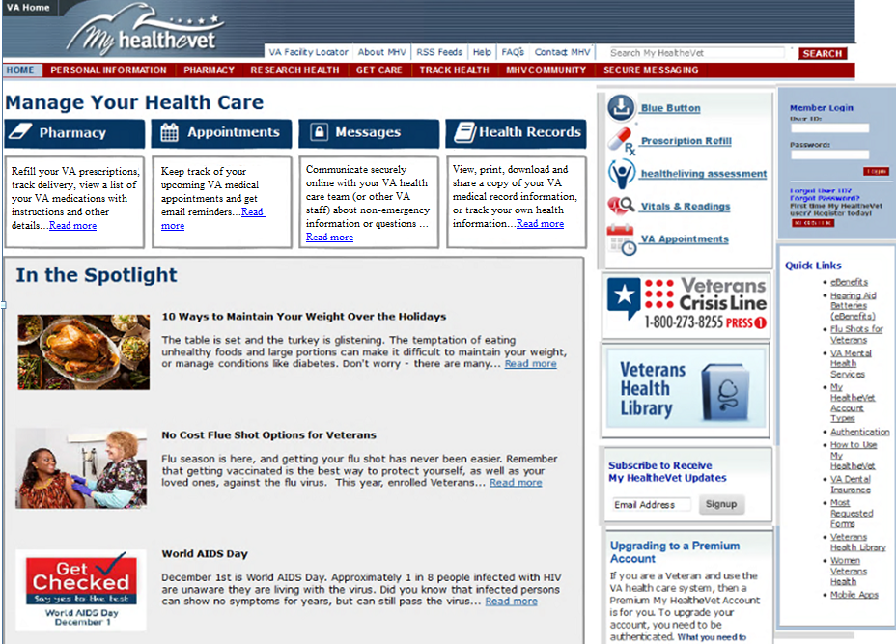

Figure 1: My Health*e*Vet Dashboard Menu Options – User Logged Out

Content Status: Approved as of 1/14/16

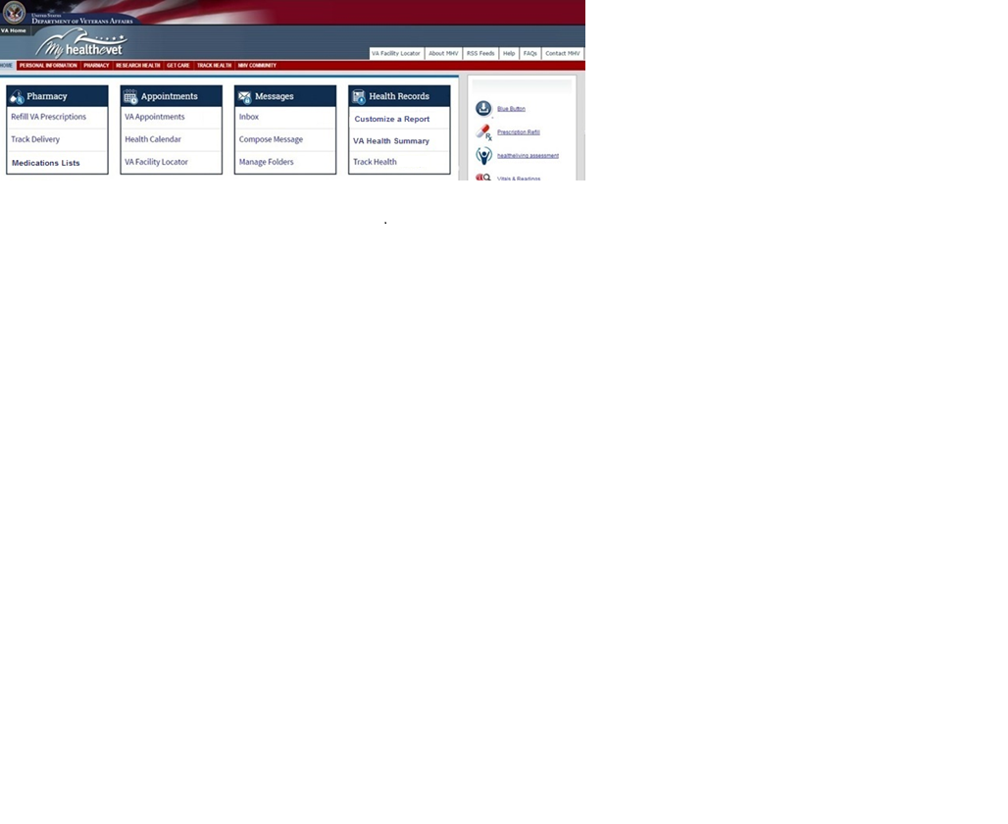

Figure 2: My Health*e*Vet Dashboard Sub Menu Options – User Logged In

Content Status: DRAFT as of 5/19/16 **(NEW Phase 2)**

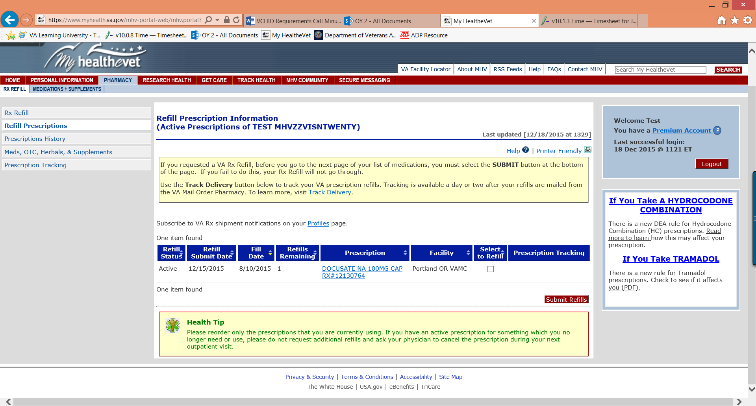

Figure 3: Refill Prescription Information

Existing Page: No changes

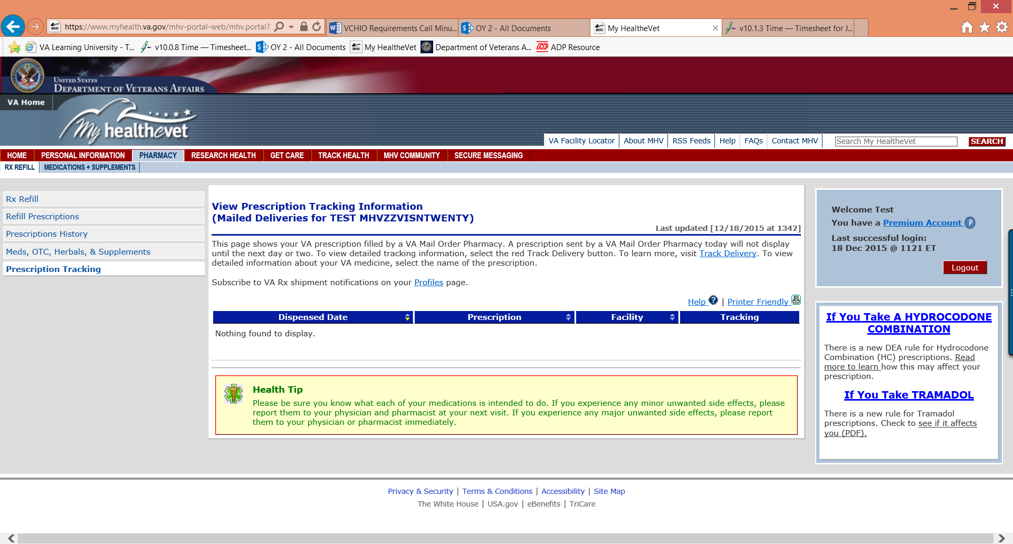

Figure 4: Track Prescription Order List

Existing Page: No changes

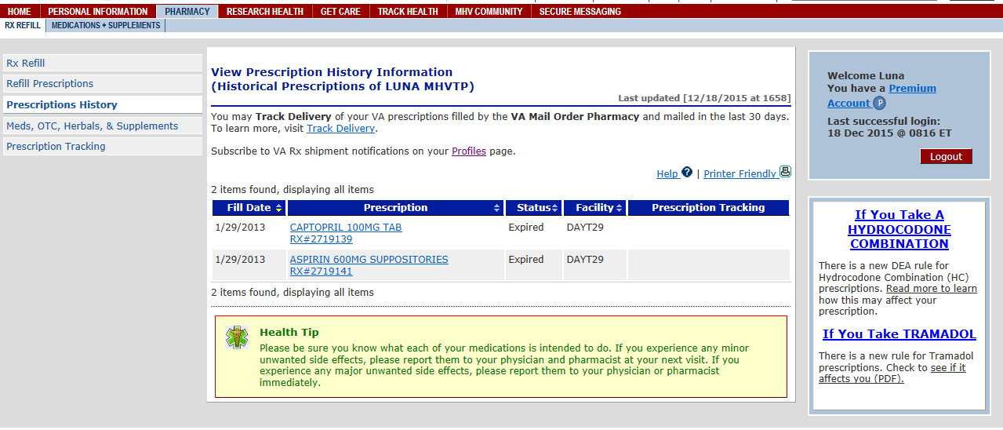

Figure 5: View Prescription History Information

Existing Page: No changes

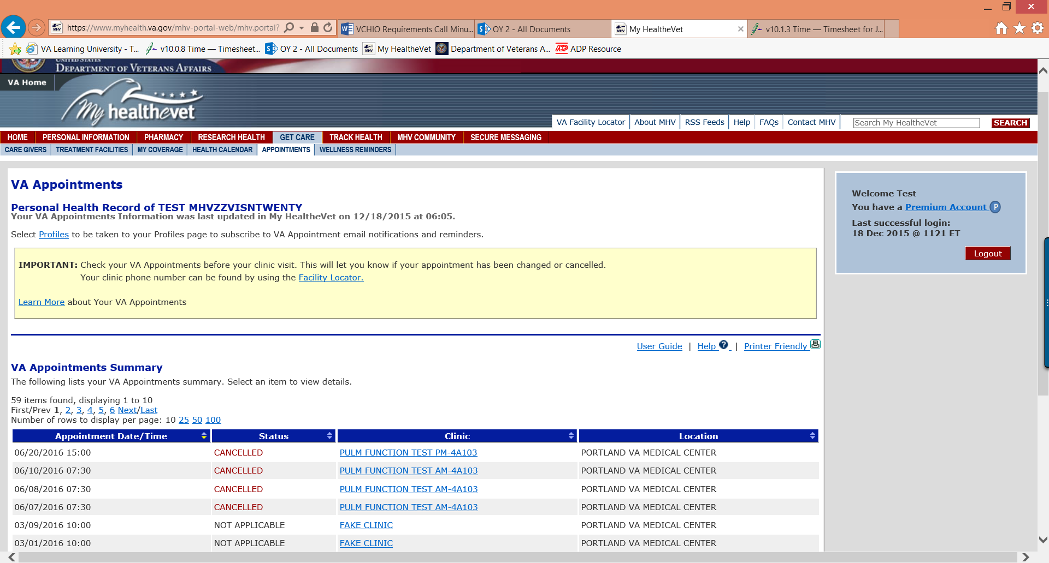

Figure 6: View Appointments

Existing Page: No changes

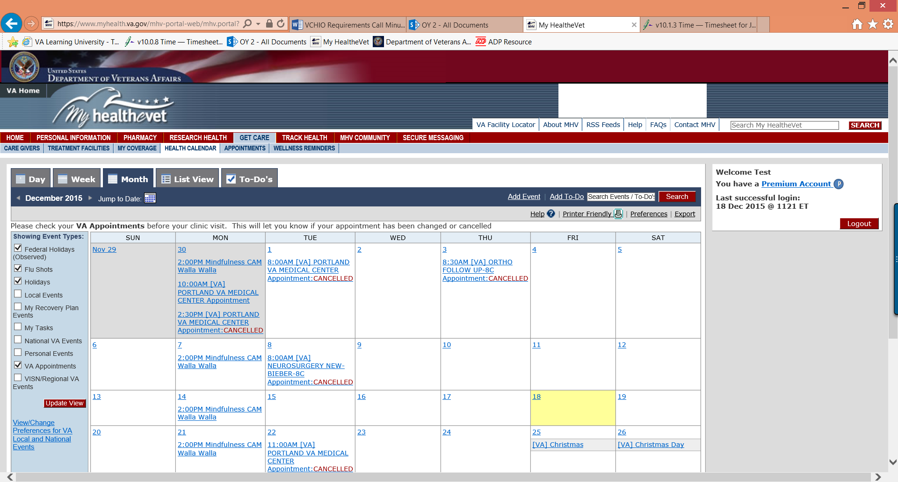

Figure 7: Health Calendar

Existing Page: No changes

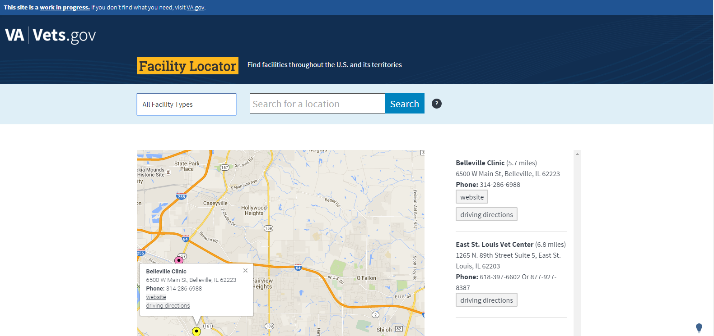

Figure 8: VA Facility Locator

Existing Page: No changes

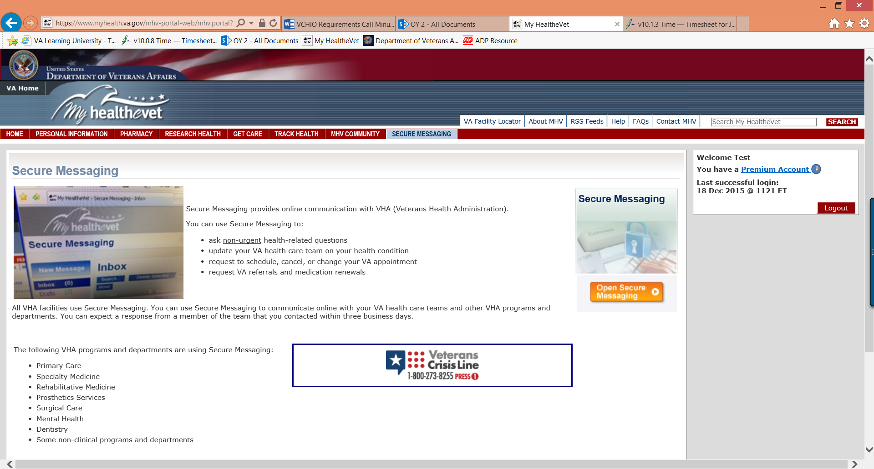

Figure 9: Secure Messaging Page

Existing Page: No changes

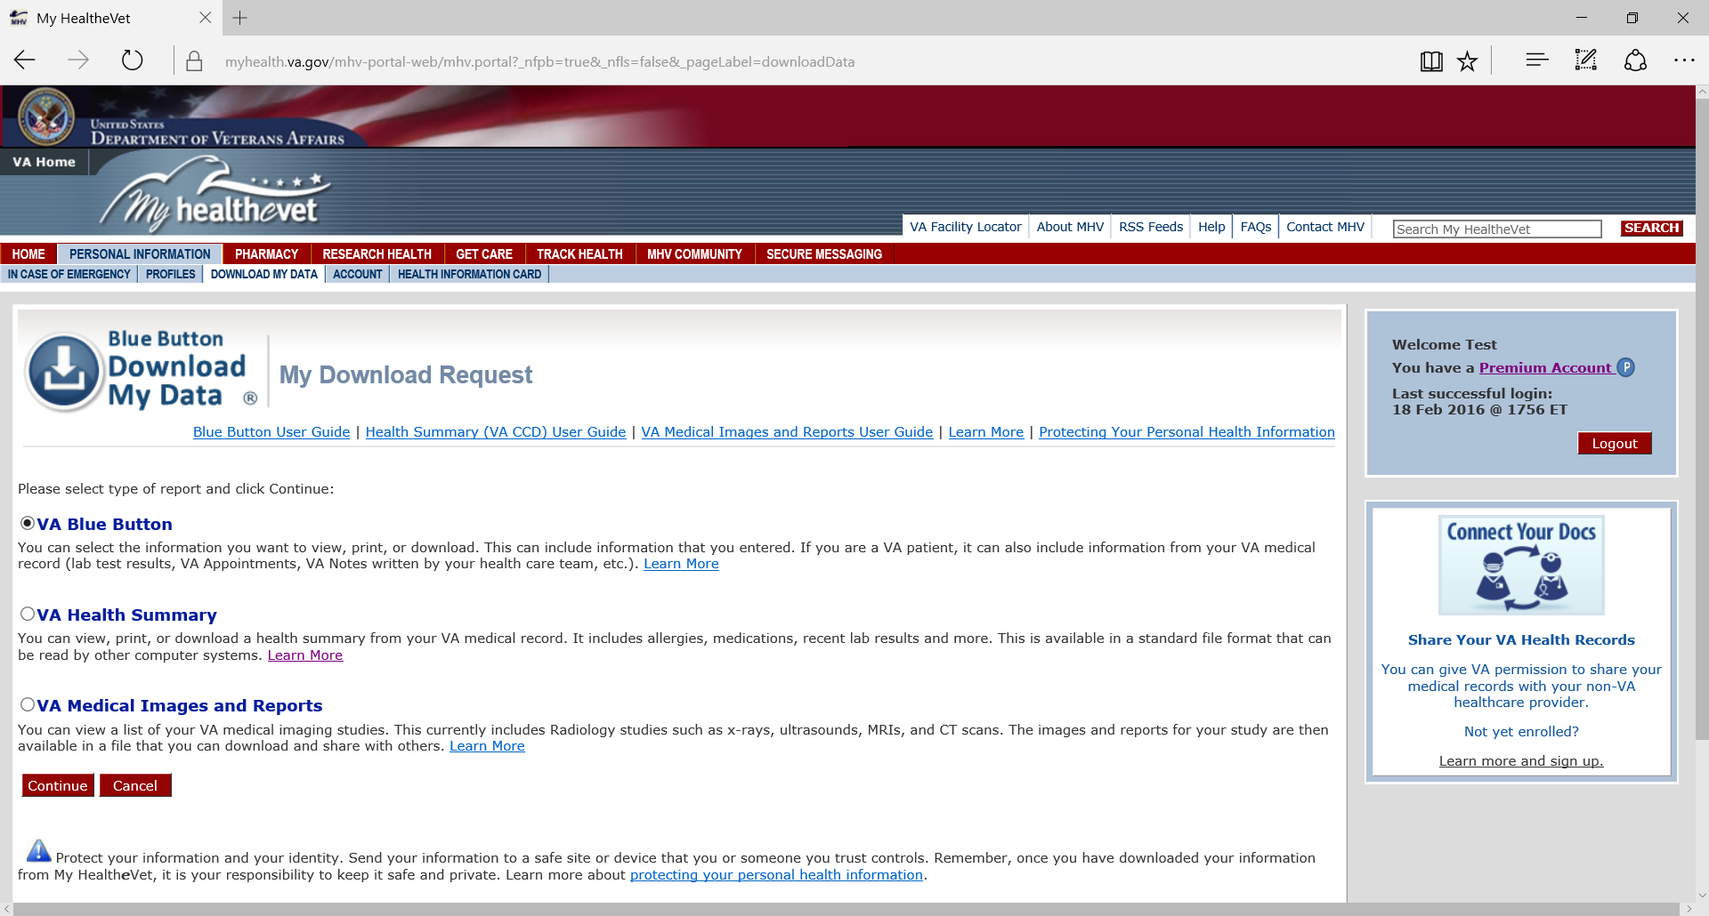Figure 10: Download Blue Button Page

Existing Page: No changes

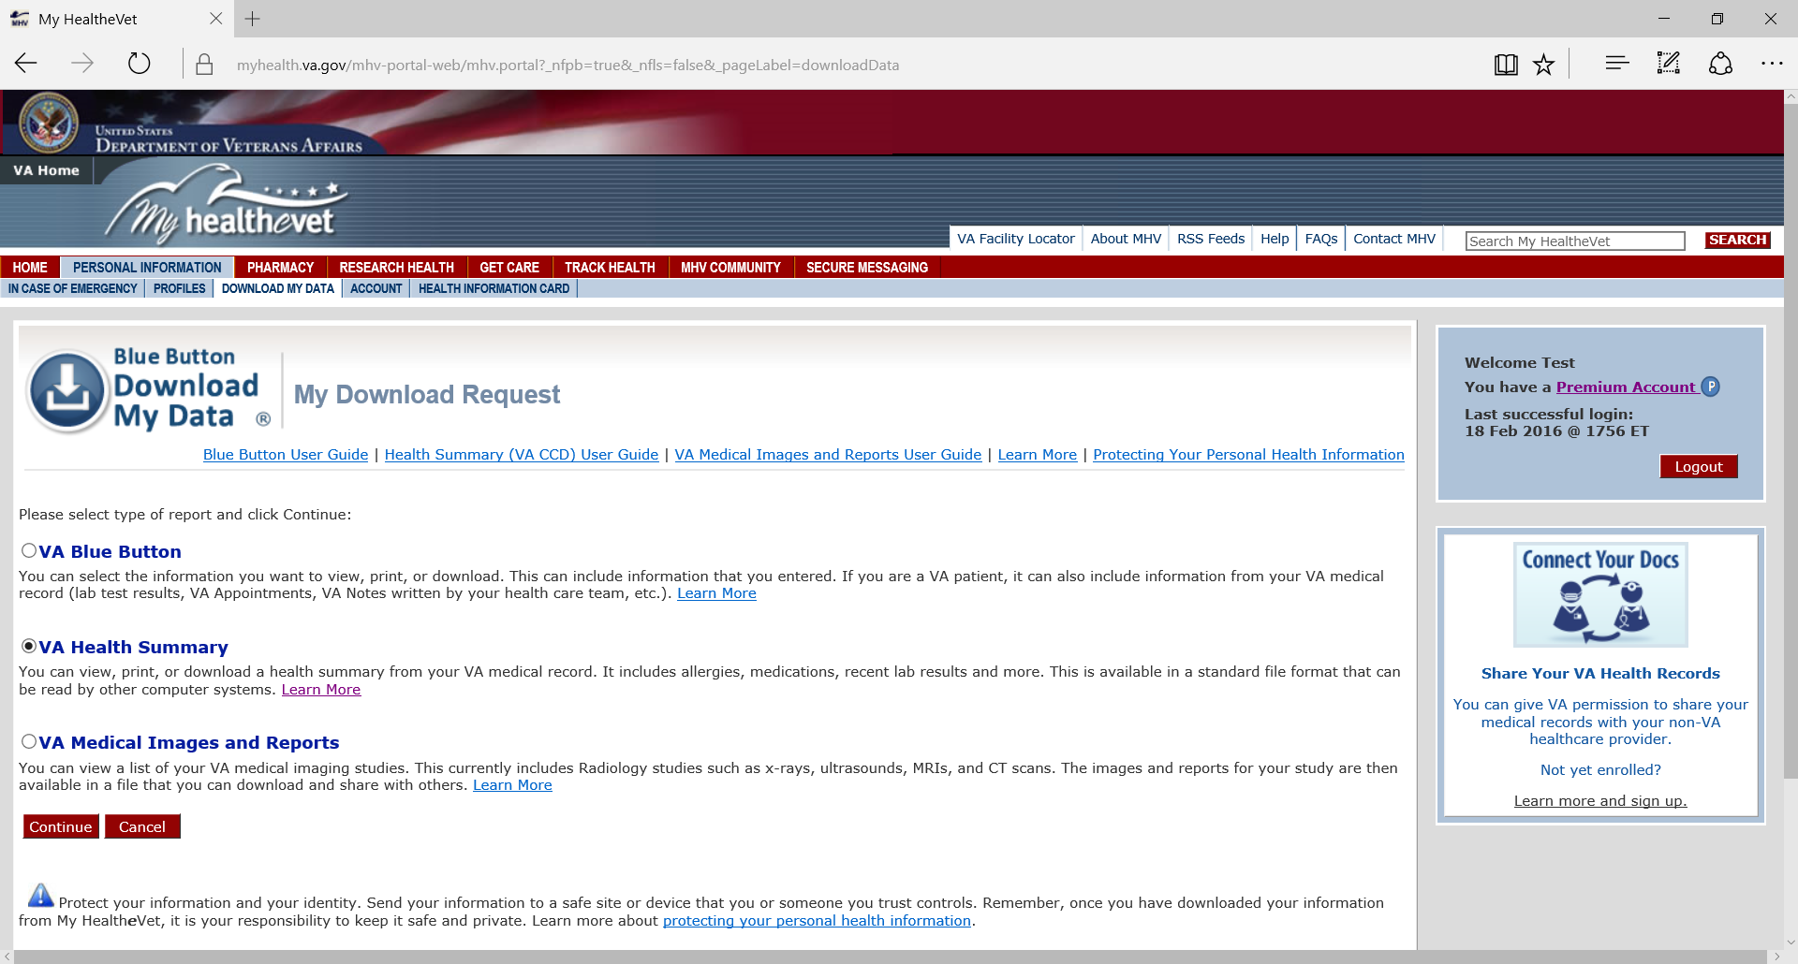Figure 11: VA Health Summary Landing Page

Existing Page: No changes

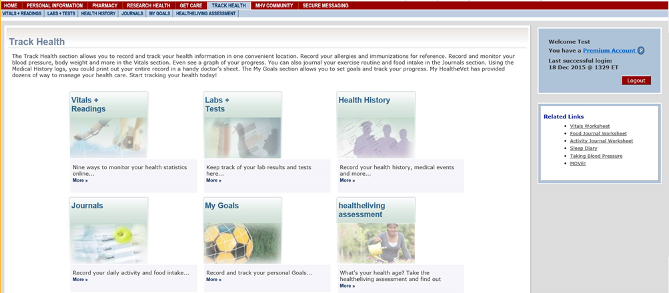

Figure 12: Track Health Landing Page

Existing Page: No changes

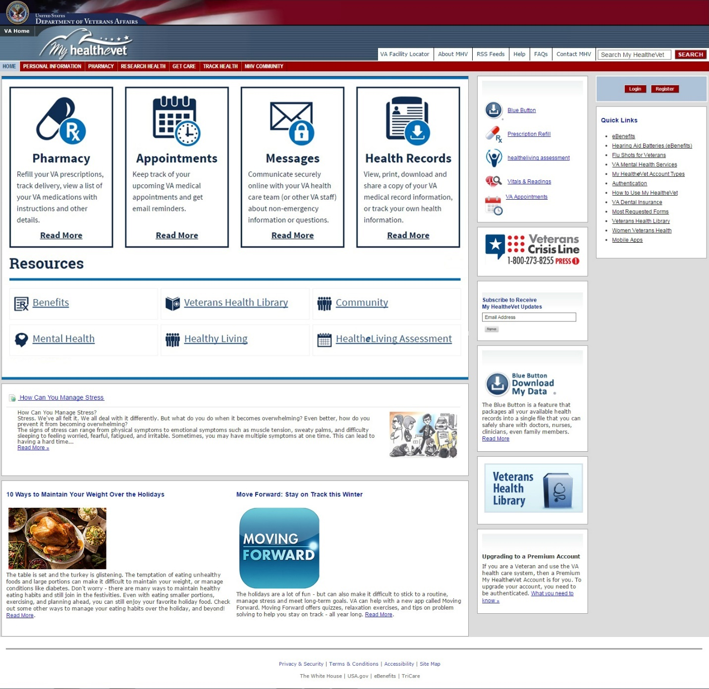

Figure 13: My Health*e*Vet Dashboard Menu Options – User Logged Out

Content Status: DRAFT as of 3/25/16 **(NEW Phase 2)**

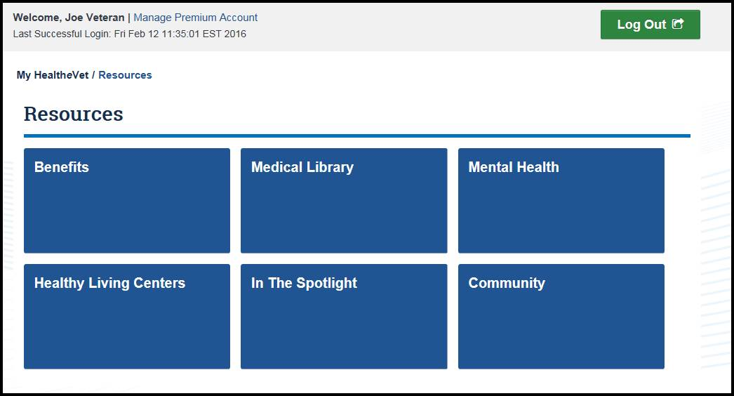

Figure 14: Show All Resources – User Logged Out

Content Status: DRAFT as of 2/16/16 **(NEW Phase 2)**

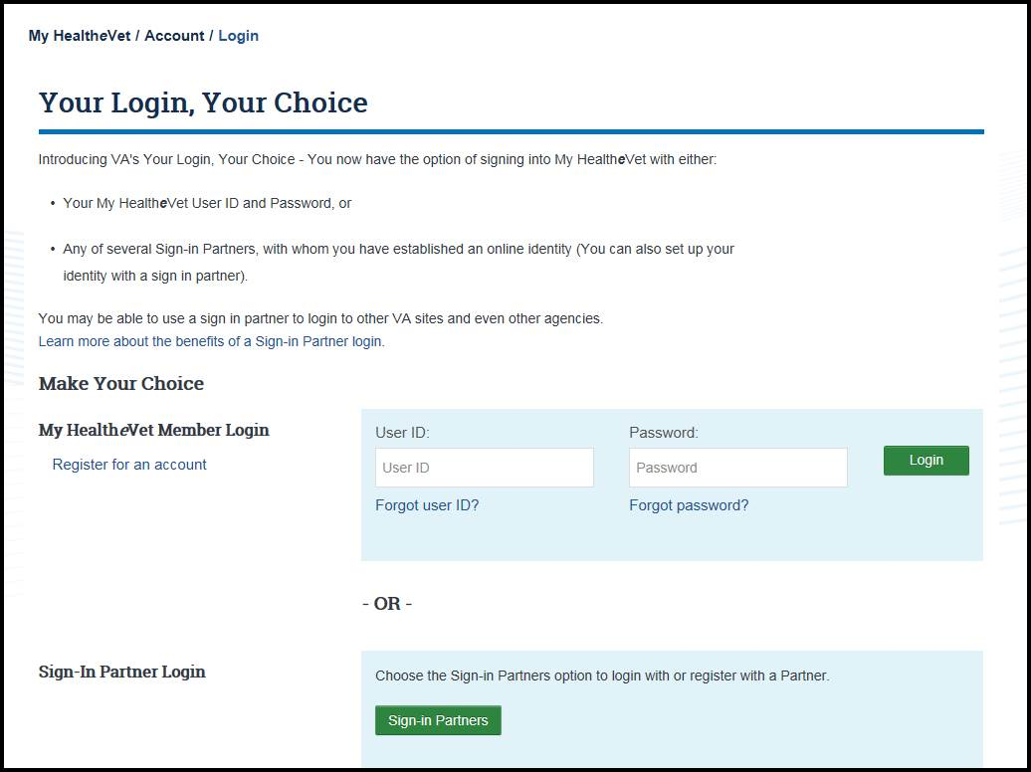

Figure 15: Login Page

Content Status: Approved as of X

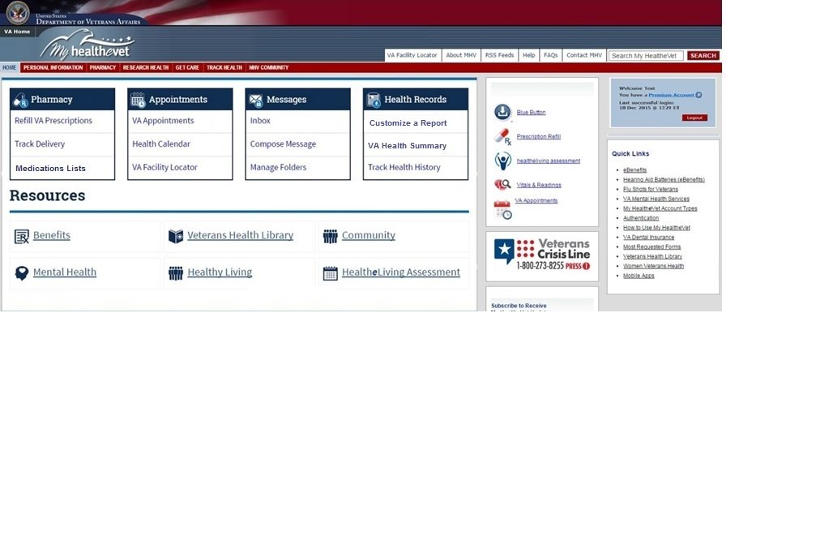

Figure 16: My Health*e*Vet Dashboard Sub Menu Options – User Logged In

Content Status: DRAFT as of 5/19/16 **(NEW Phase 2)**

Appendix C Pharmacy Article URL Link

This Pharmacy Article:

<https://myhealth.va.gov/mhv-portal-web/anonymous.portal?_nfpb=true&_nfto=false&_pageLabel=spotlightArchive&contentPage=spotlight/10162012_Rx_Refill.html>

Content Status: Approved as of 1/14/16

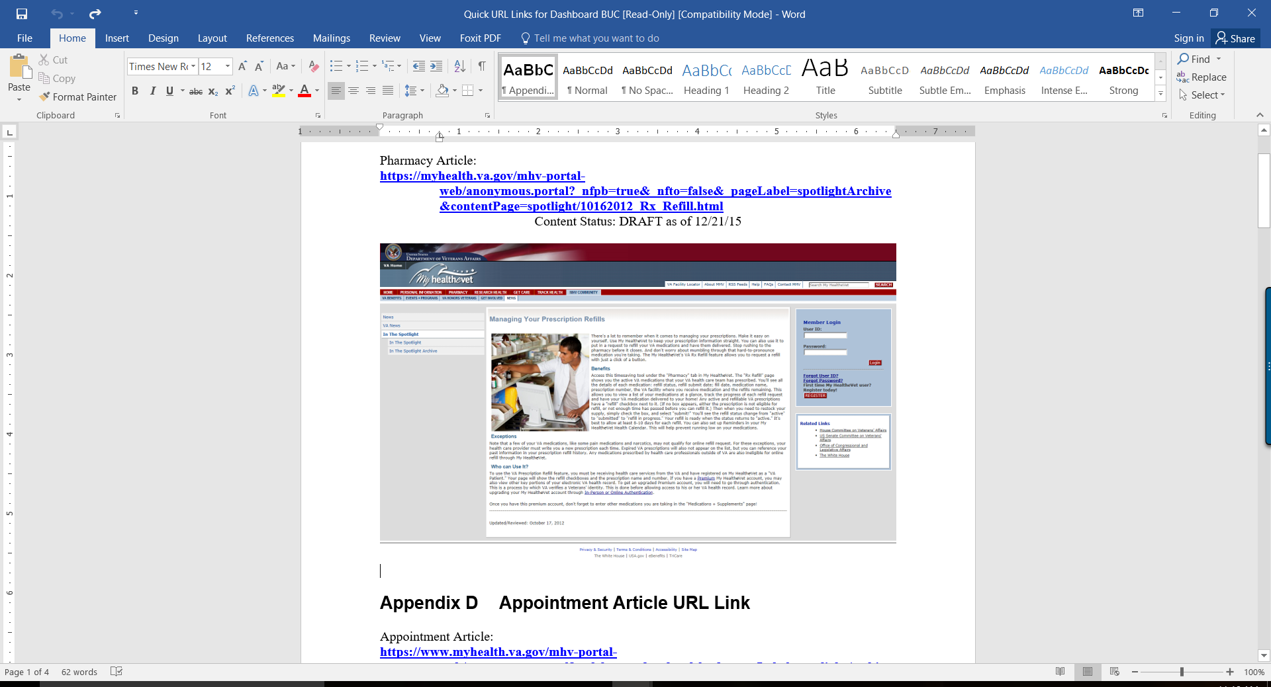Figure 17: Managing Your Prescription Refills

Content Status: Approved as of 1/14/16

Appendix D Appointment Article URL Link

Appointment Article:

<https://www.myhealth.va.gov/mhv-portal-web/anonymous.portal?_nfpb=true&_nfto=false&_pageLabel=spotlightArchive&contentPage=spotlight/10162012_Appointments.html>

Content Status: Approved as of 1/14/16

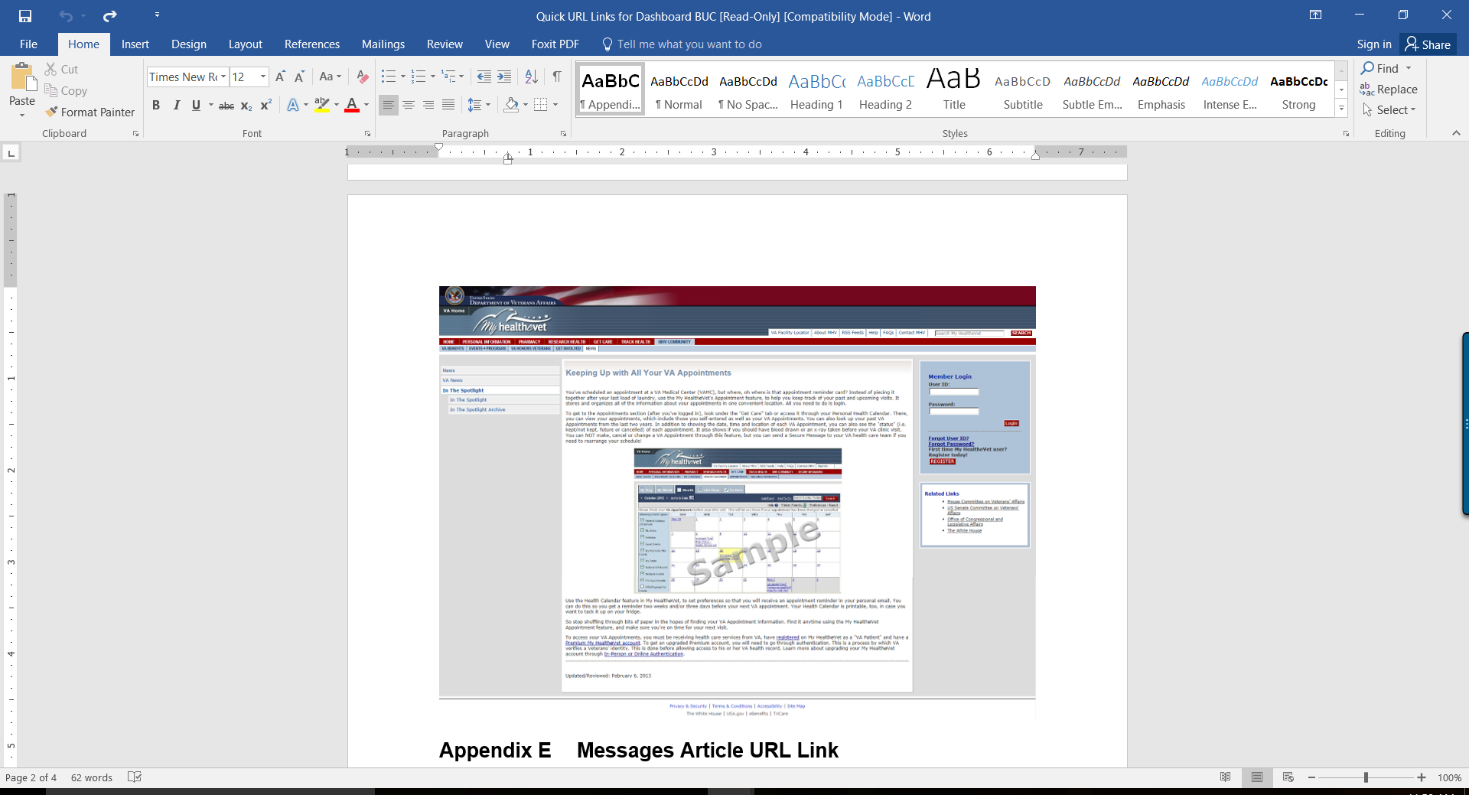

Figure 18: Keeping Up with All Your Appointments

Content Status: Approved as of 1/14/16

Appendix E Messages Article URL Link

Secure Messaging Article:

<https://www.myhealth.va.gov/mhv-portal-web/anonymous.portal?_nfpb=true&_nfto=false&_pageLabel=spotlightArchive&contentPage=spotlight/10162012_SecureMessaging.html>

Content Status: Approved as of 1/14/16

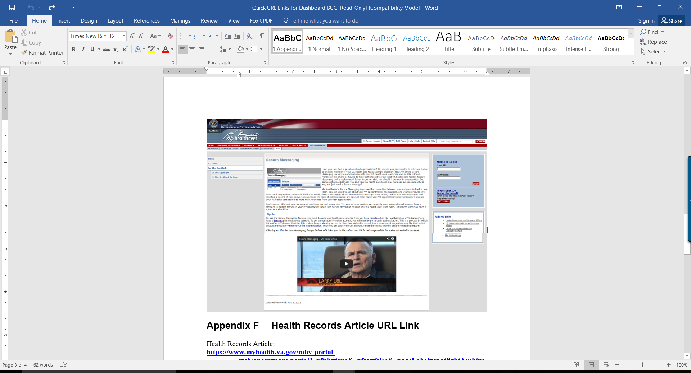

Figure 19: Secure Messaging

Content Status: Approved as of 1/14/16

Appendix F Health Records Article URL Link

Health Records Article:

<https://www.myhealth.va.gov/mhv-portal-web/anonymous.portal?_nfpb=true&_nfto=false&_pageLabel=spotlightArchive&contentPage=spotlight/01192013_EvergreenBlueButton.html&WT.ac=home_BlueButton_top_tasks>

Content Status: Approved as of 1/14/16

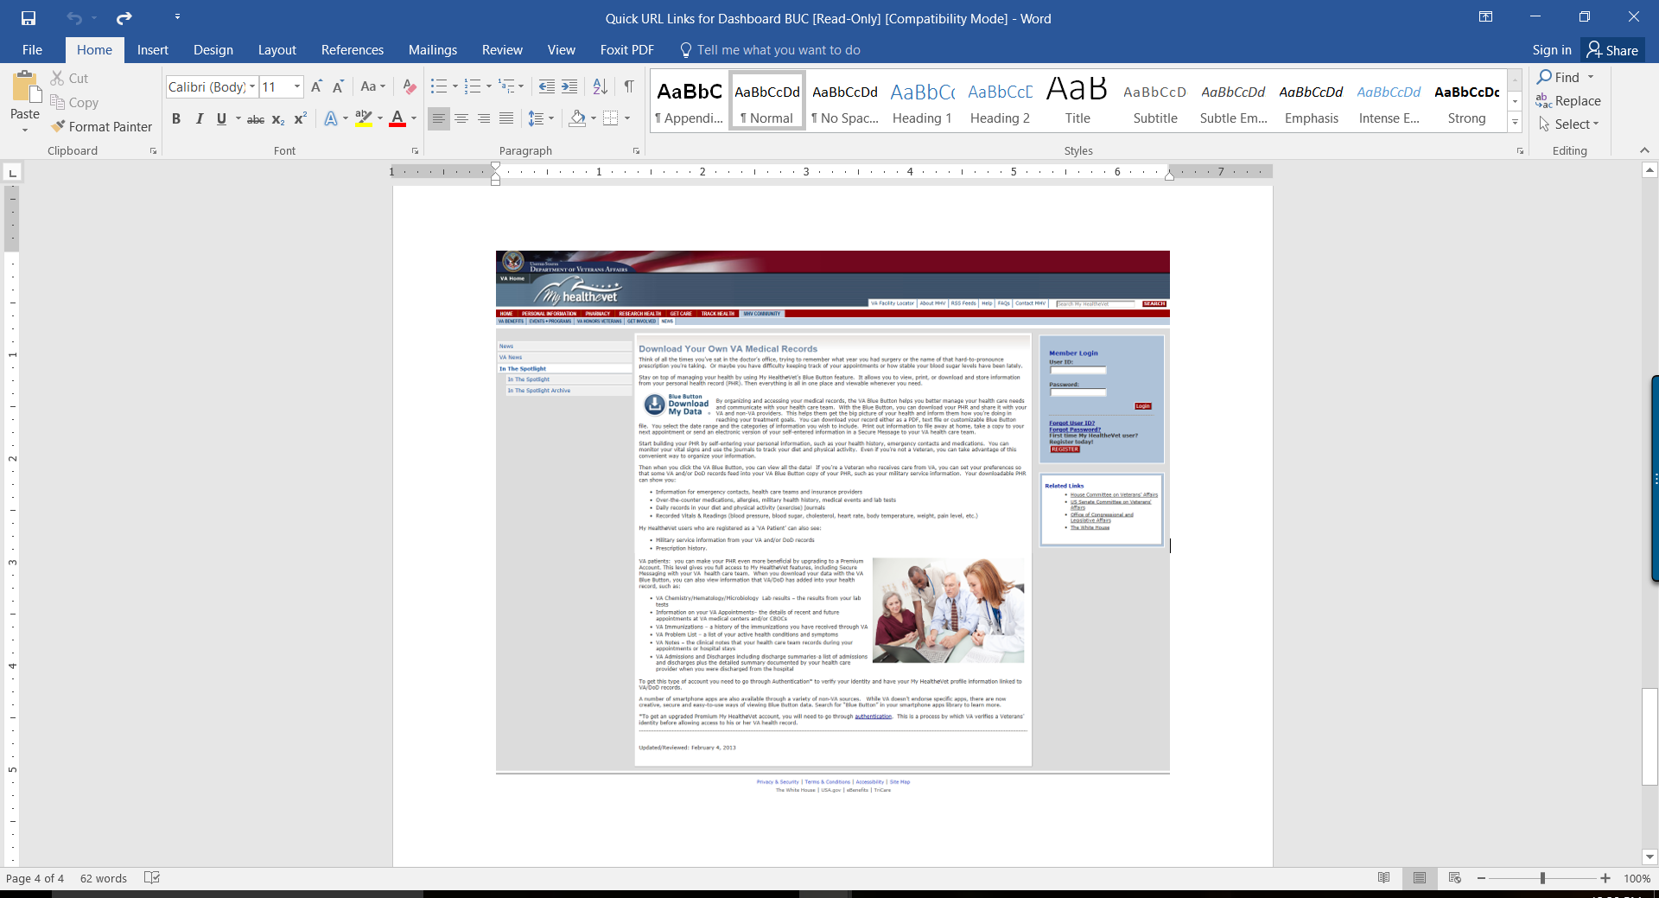

Figure 20: Download Your own VA Medical Records

Content Status: Approved as of 1/14/16

Appendix G MHV Splash Page

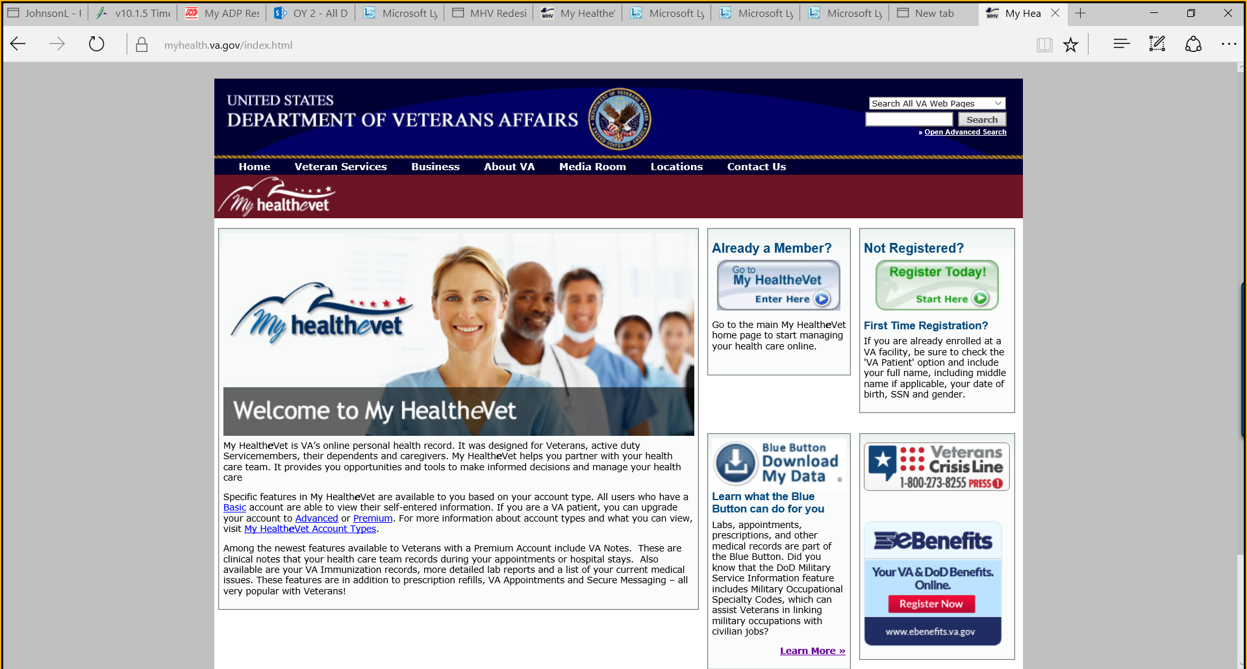

Figure 21: MHV Splash page

Will be removed

Appendix H Account Messages

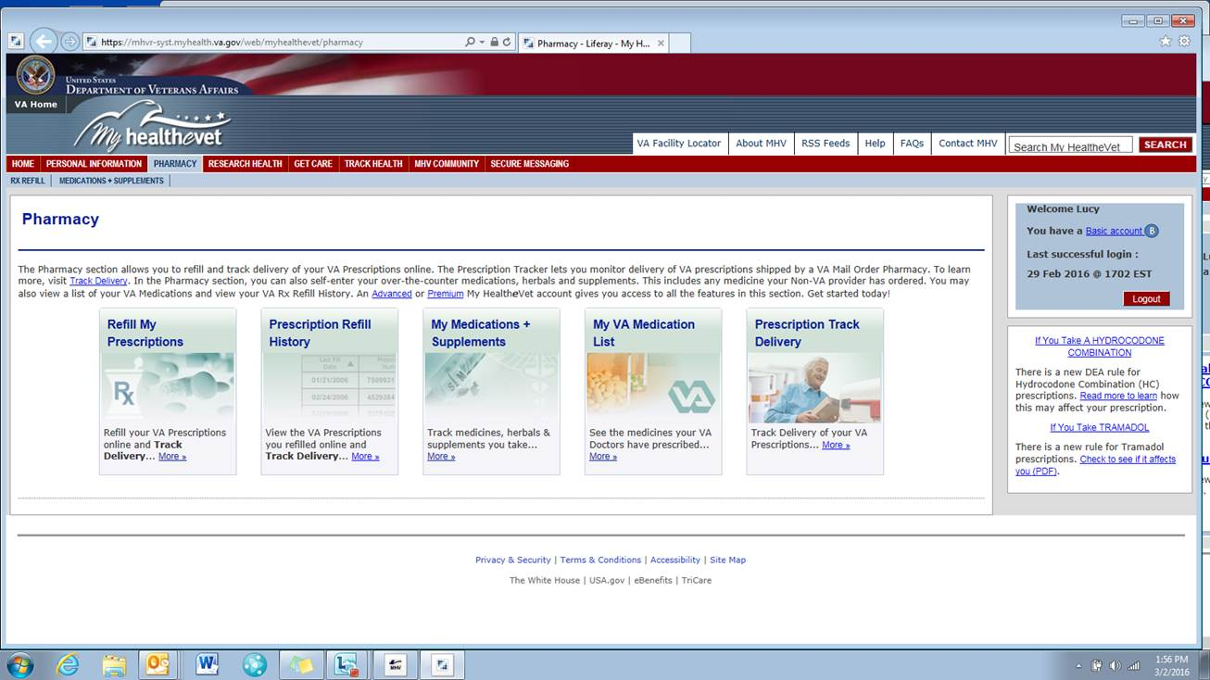

Figure 22: Basic Account Message

Existing Page: No changes

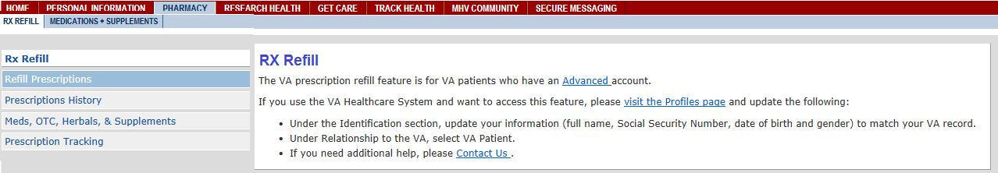

Figure 23: Non-VA Patient Basic or Advanced User Logged In – RX Refill Landing Page

Approval Status:Draft as of 3/8/16

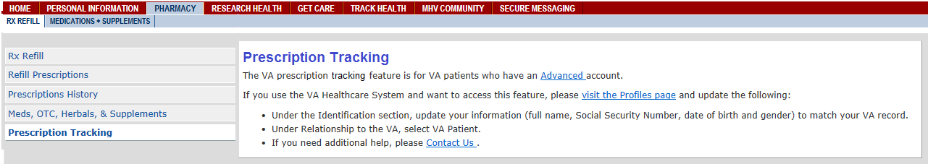

Figure 24: Non-VA Patient Basic or Advanced User Logged In -Prescription Tracking

Approval Status:Draft as of 3/8/16

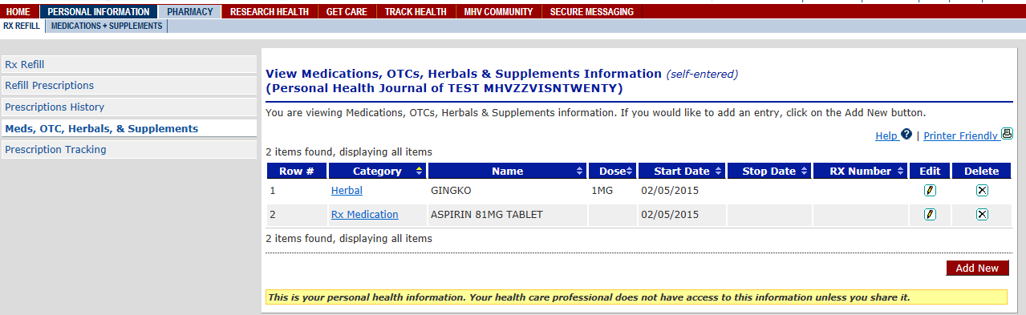

Figure 25: Non-VA Patient Basic or Advanced User Logged In -Medication, OTCs, Herbals & Supplements

Approval Status:Existing Functionality

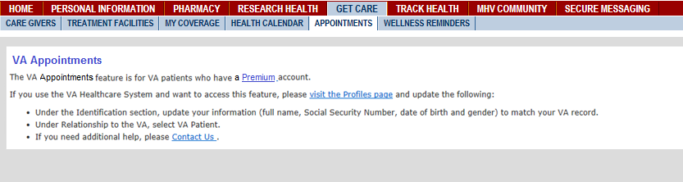

Figure 26: Non-VA Patient Basic or Advanced User Logged In – VA Appointments

Approval Status:Draft as of 3/8/16 (Will need updates)

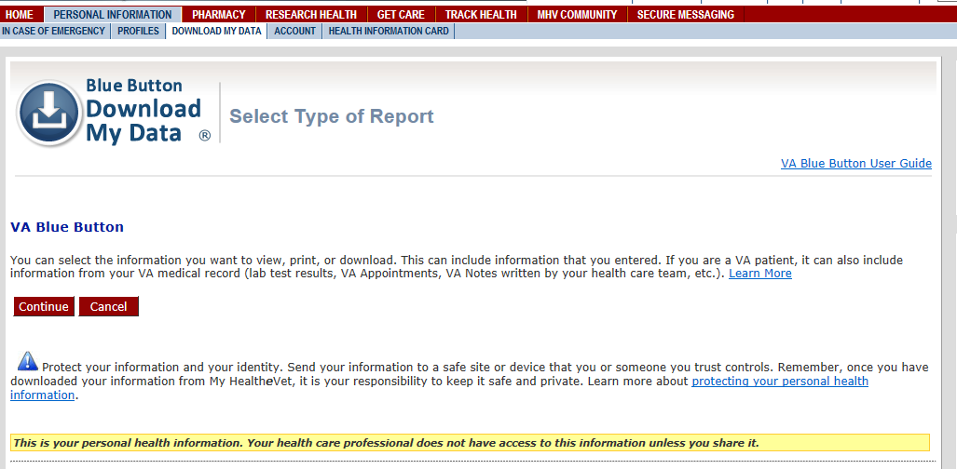

Figure 27: Non-VA Patient Basic or Advanced User Logged In – Health Records

Approval Status:Existing Functionality

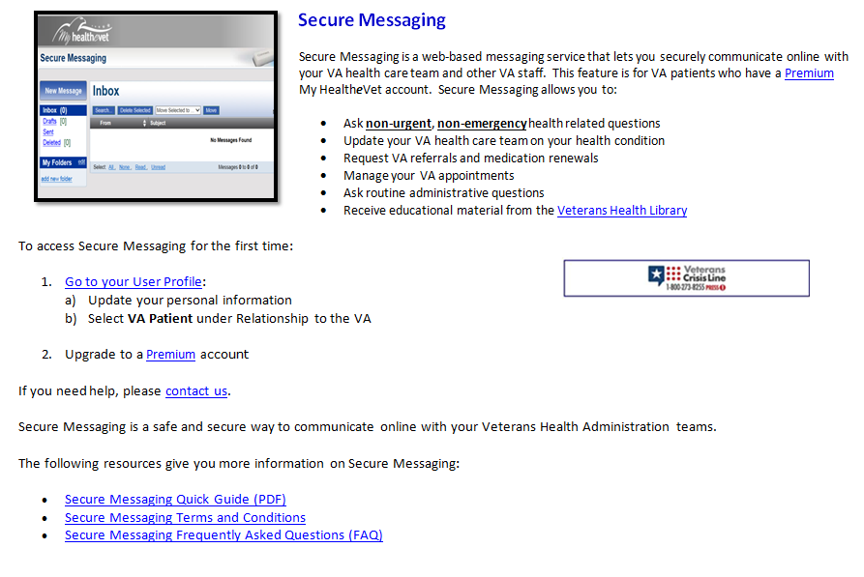Figure 28: VA Patient with Advanced User Access – Secure Messaging

Approval Status:Approved 4/18/16

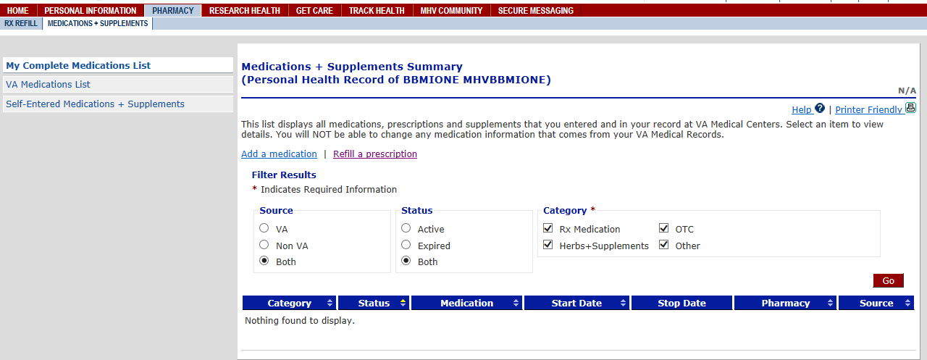

Figure 29:

Approval Status: Existing Functionality

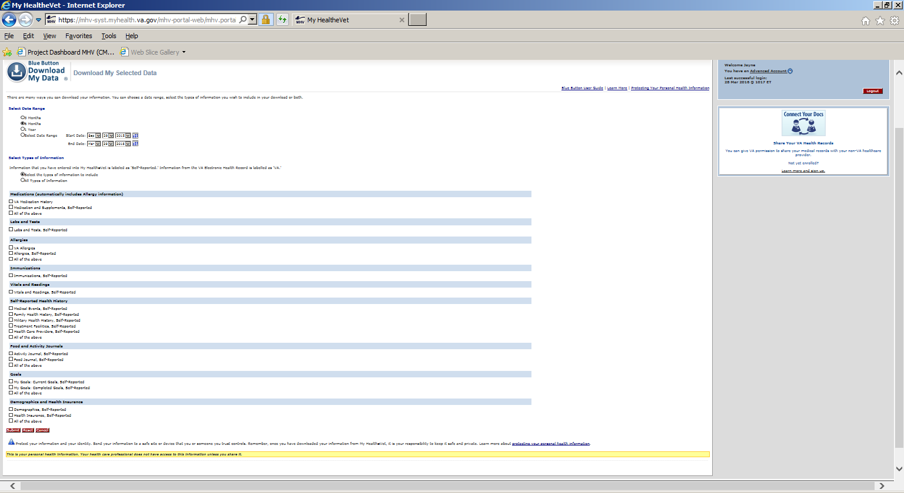

Figure 30: Download My Data – User Select “Continue”

Existing Functionality

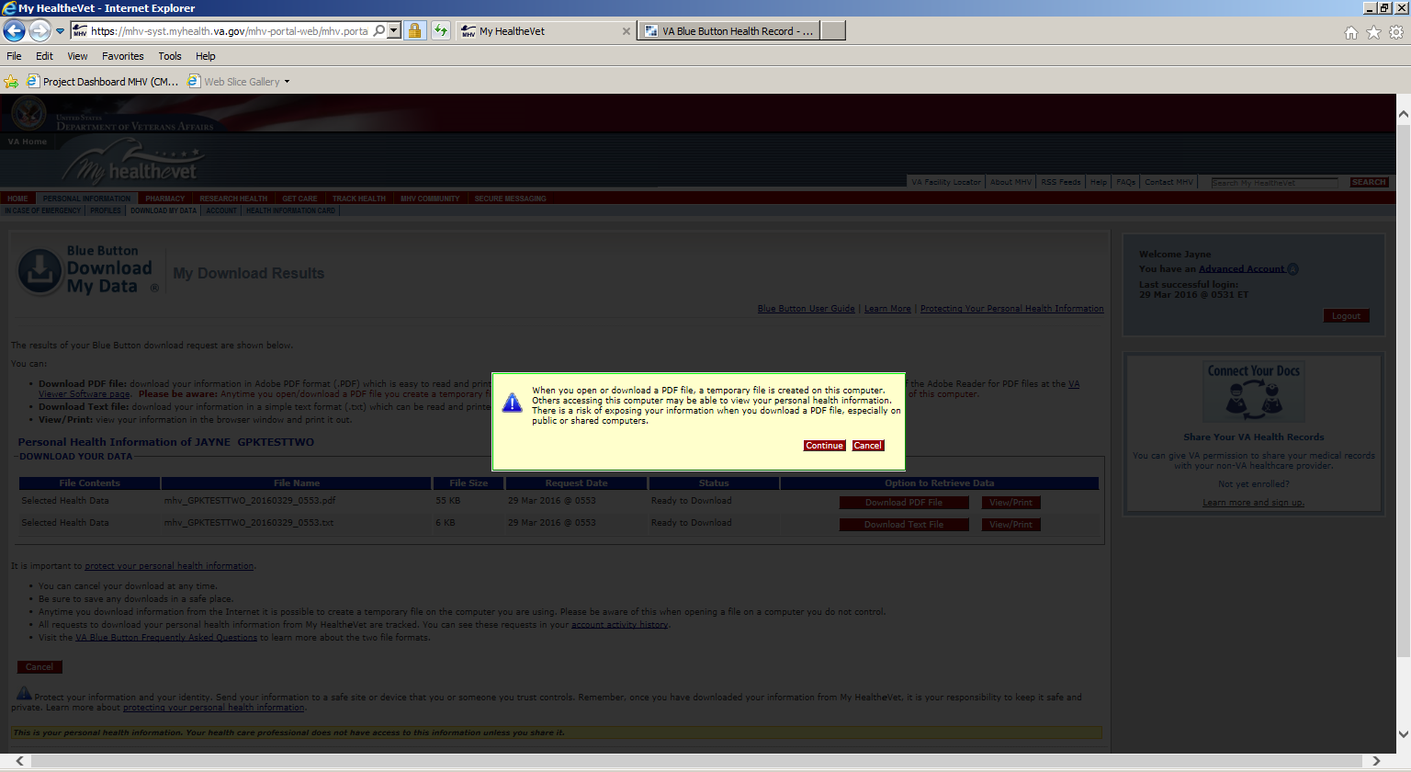

Figure 31: Download My Data – Message pop up

Existing Functionality

Resource Link – Benefits

<https://myhealth.va.gov/mhv-portal-web/anonymous.portal?_nfpb=true&_nfto=false&_pageLabel=vaBenefitsHome>

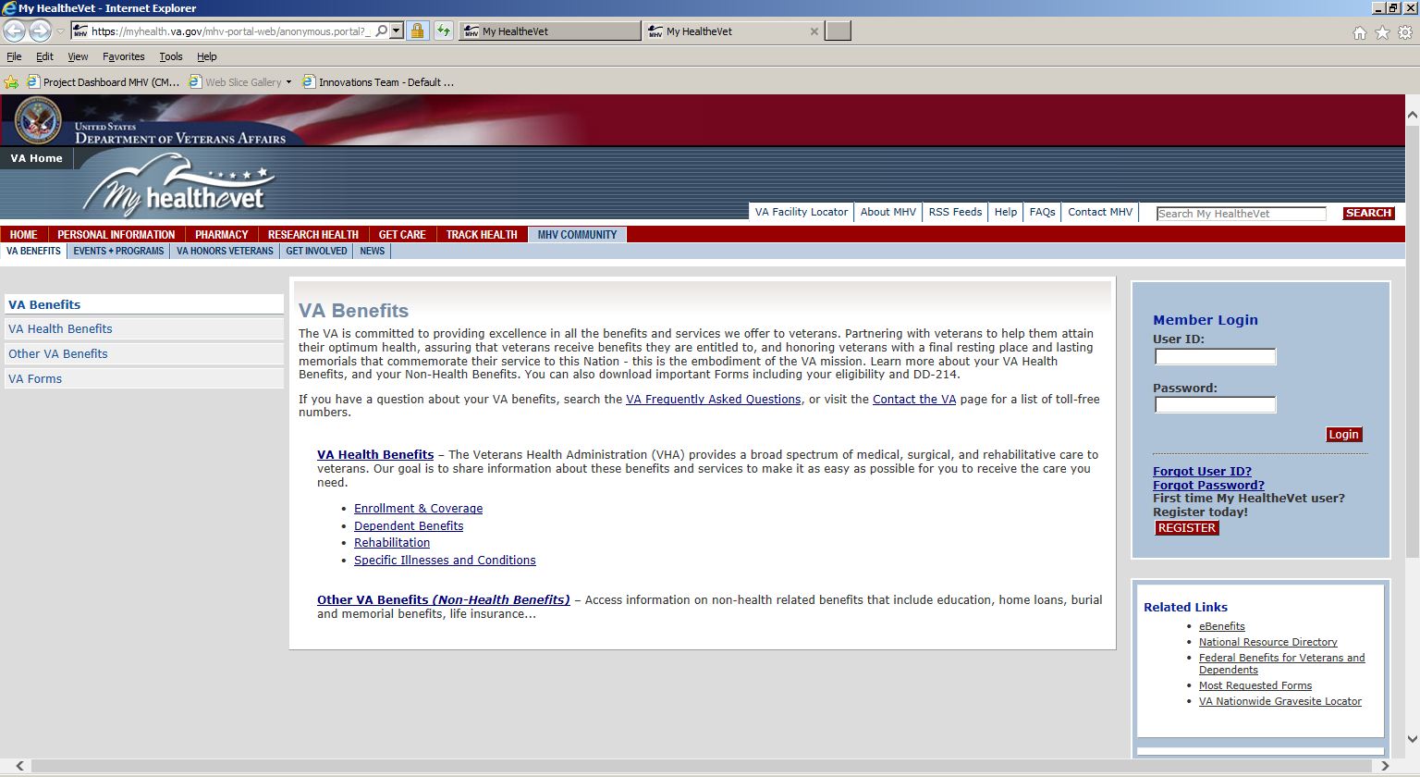

Figure 32: Resource Link – Benefits

Existing Functionality

Resource Link – Mental Health

<https://myhealth.va.gov/mhv-portal-web/mhv.portal?_nfpb=true&_pageLabel=mentalHealth&_nfls=false>

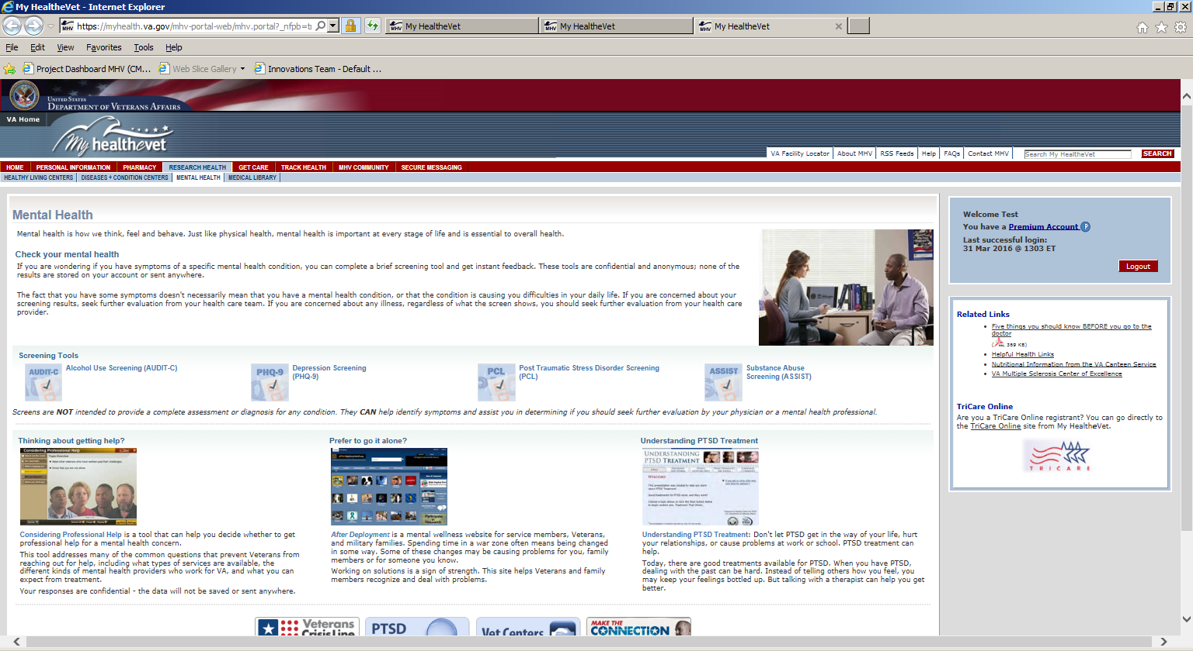

Figure 33: Resource Link – Mental Health

Existing Functionality

Resource Link – Community

<https://myhealth.va.gov/mhv-portal-web/mhv.portal?_nfpb=true&_nfto=false&_pageLabel=mhvCommunityHome>

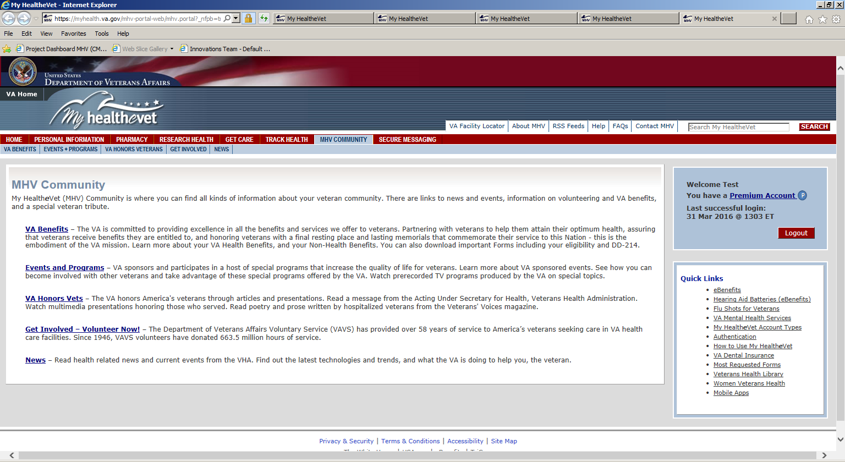

Figure 34: Resource Link – Community

Existing Functionality

Resource Link – Veteran’s Health Library

<http://www.veteranshealthlibrary.org/>

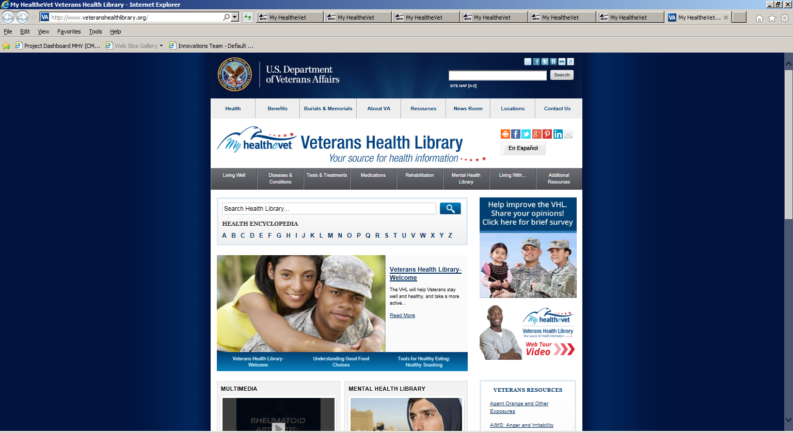

Figure 35: Resource Link – Veteran’s Health Library

Existing Functionality

Resource Link – Healthy Living

<https://myhealth.va.gov/mhv-portal-web/mhv.portal?_nfpb=true&_pageLabel=healthyLiving&_nfls=false>

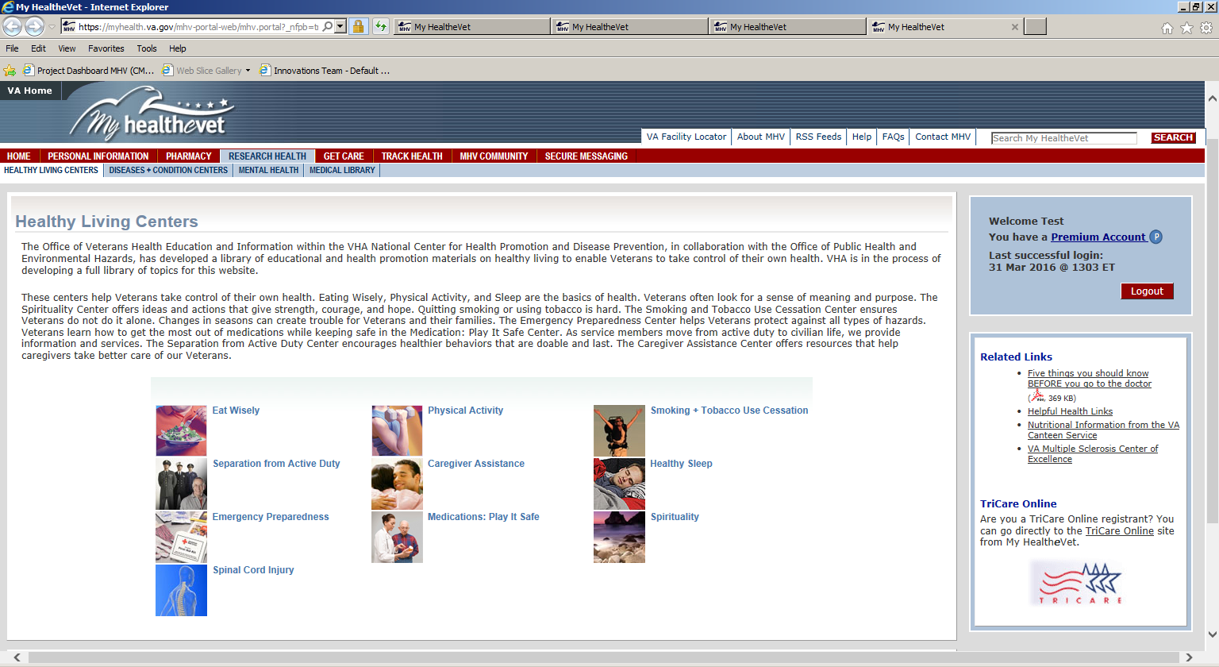

Figure 36: Resource Link – Healthy Living

Existing Functionality

Resource Link – Health Calendar – Logged In

<https://myhealth.va.gov/mhv-portal-web/mhv.portal?_nfpb=true&_pageLabel=healthCalendar&_nfls=false>

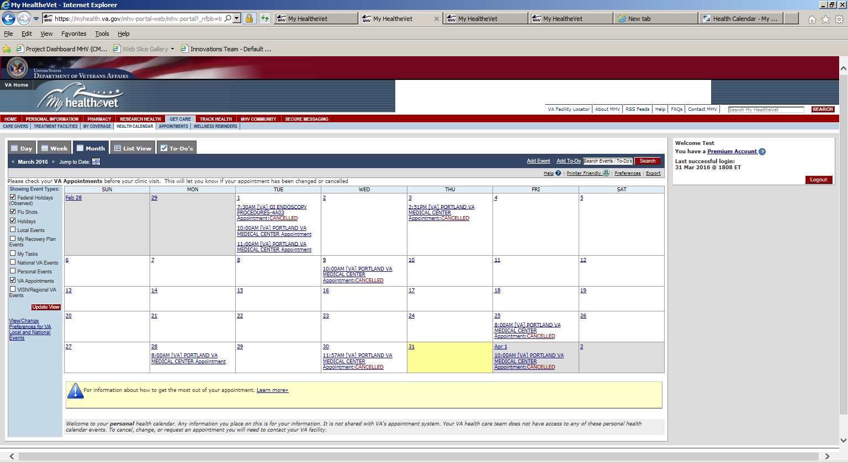

Figure 37: Resource Link – Health Calendar – Logged In

Existing Functionality

Resource Link – Health*e*Living Assessment – User Logged In

<https://myhealth.va.gov/mhv-portal-web/mhv.portal?_nfpb=true&_pageLabel=assessHealth&_nfls=false>

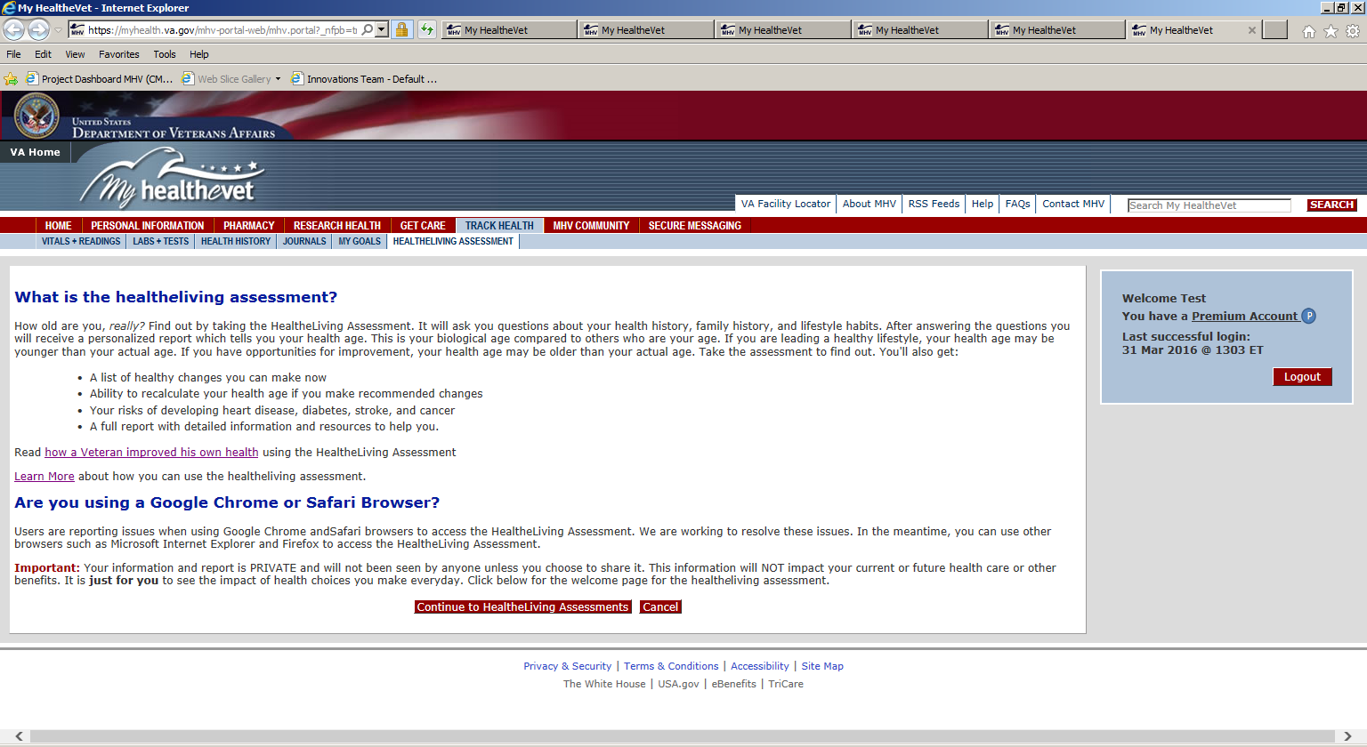

Figure 38: Resource Link – Health*e*Living Assessment – User Logged In

Existing Functionality

Resource Link – Health*e*Living Assessment – User Not Logged In

<https://myhealth.va.gov/mhv-portal-web/anonymous.portal?_nfpb=true&_pageLabel=assessHealth&_nfls=false>

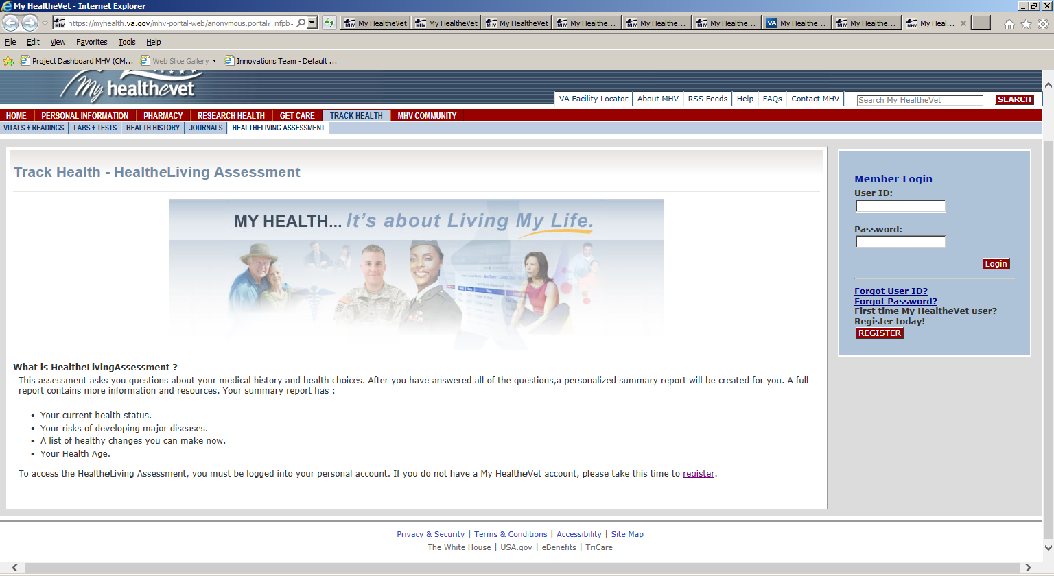

Figure 39: Resource Link – Health*e*Living Assessment – User Not Logged In

Existing Functionality

Resource Link – Health Calendar – User Not Logged In

<https://myhealth.va.gov/mhv-portal-web/mhv.portal?_nfpb=true&_nfto=false&_pageLabel=spotlightArchive&contentPage=spotlight/10162012_Appointments.html>

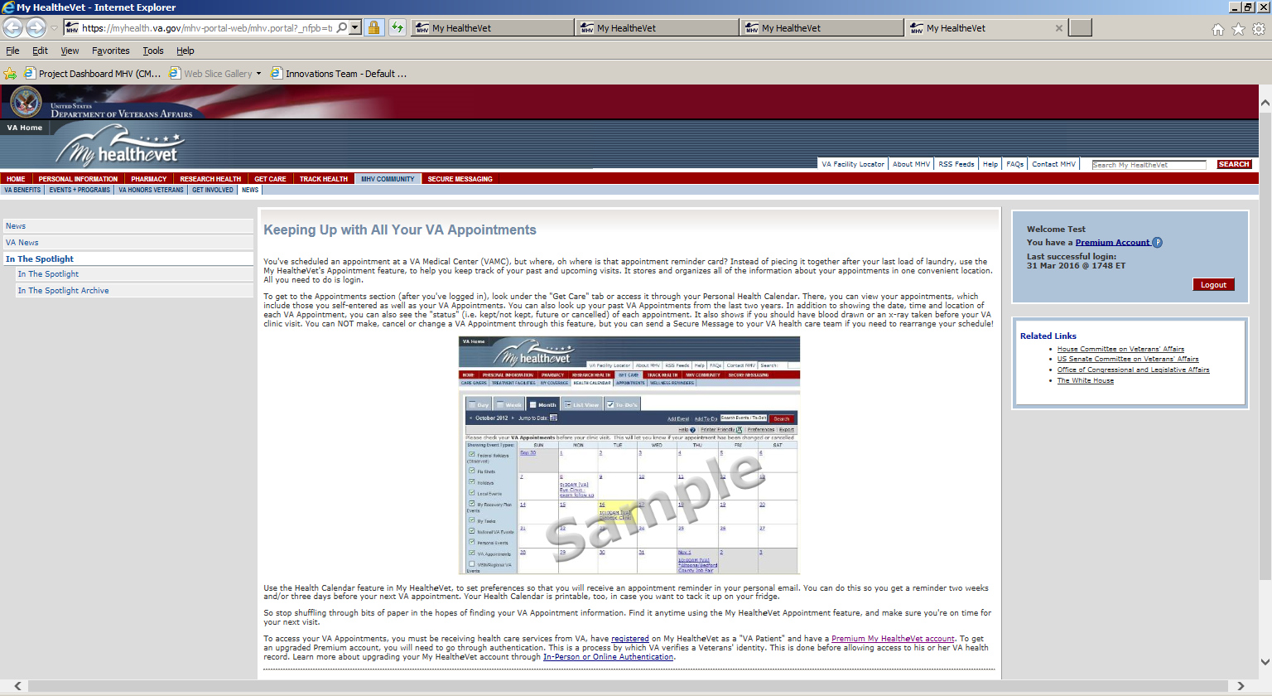

Figure 40: Resource Link - Health Calendar – User Not Logged In

Existing Functionality

Show All Resources Link

<https://mhvred-intb.myhealth.va.gov/web/myhealthevet/health-resources>

Figure 41: Show All Resources Link

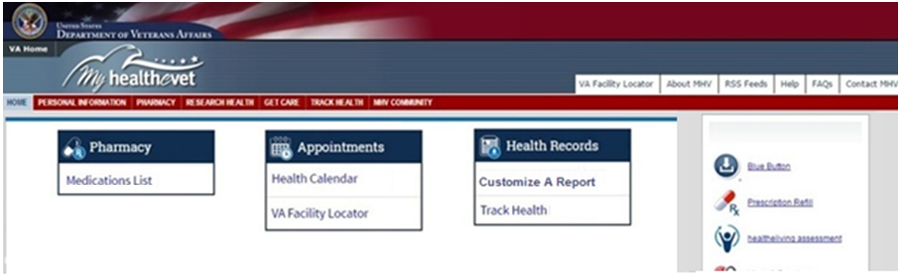

Figure 42: Dashboard for a User Logged In as a Non-VA Patient with a Basic or Advanced Account

Content Status: **Draft as of 5/19/16**

Appendix I Approval Signatures

The requirements defined in this document are the high level business requirements necessary to meet the strategic goals and operational plans of the Veterans/Consumers Health Informatics Office.

**My Health*e*Vet Program Management Office**

Signifies that the customer approves the documented requirements, that they adequately represent the customers desired needs, and that the customer agrees with the defined scope for the Business Use Case.

Signed: Date:

Theresa Hancock, Director, Veterans/Consumers Health Informatics Office